Mass and Capacity

Learning Objective: To estimate and measure mass and capacity using appropriate standard units.
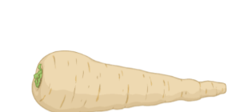
Task: Measure the number of millilitres, litres, grams, or kilograms using each method of measurement.
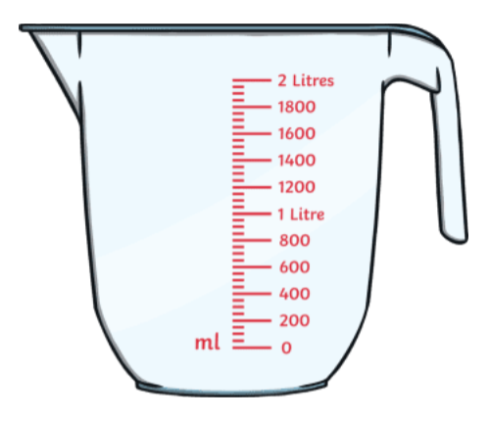
Method of measurement:

Unit of measurement:

Measurement:
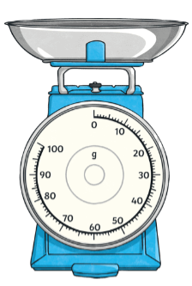
Method of measurement:

Unit of measurement:

Measurement:

Method of measurement:

Unit of measurement:

Measurement:

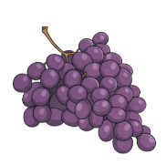
Method of measurement:

Unit of measurement:

Measurement:
Method of measurement:

Unit of measurement:

Measurement:

Method of measurement:

Unit of measurement:

Measurement:

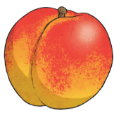

Method of measurement:

Unit of measurement:

Measurement:
Method of measurement:

Unit of measurement:

Measurement:

