Estimating lengths

Learning Objectives: to estimate and measure length using appropriate standard units.
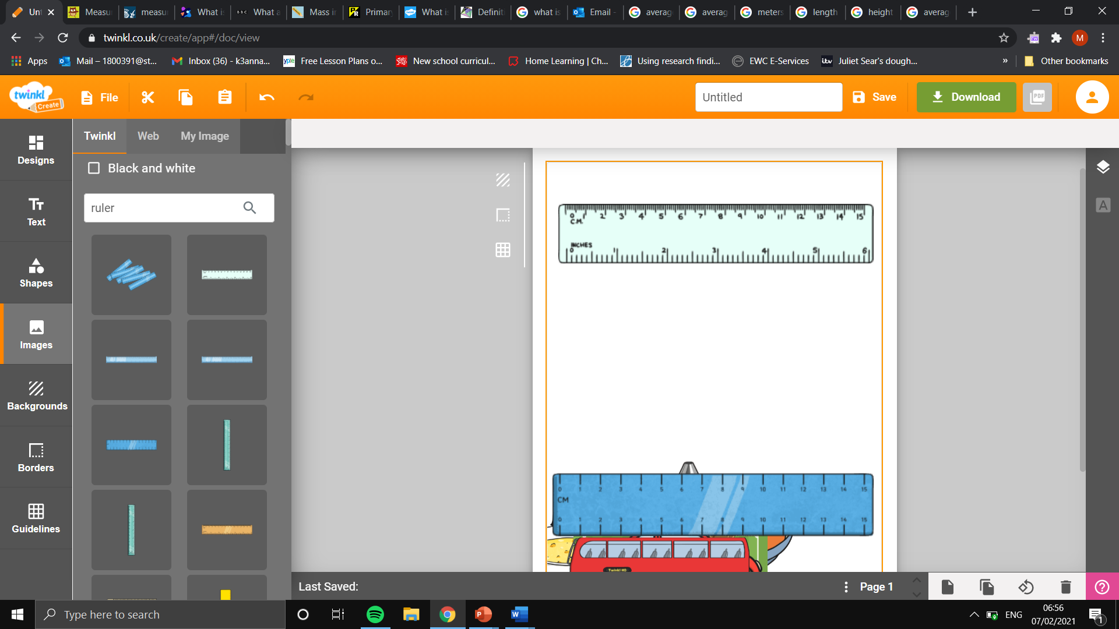
Task: using the ruler, estimate the measurement on the ruler in centimetres.

10.1cm
5.5 cm
1.8 cm

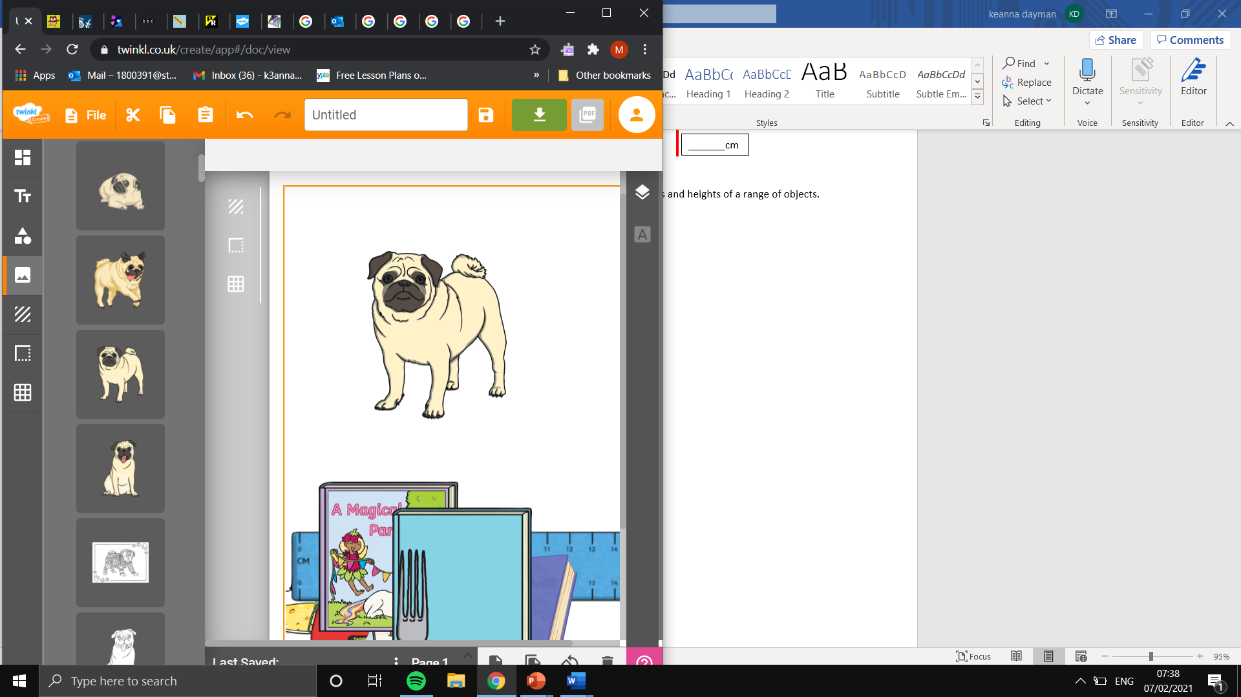
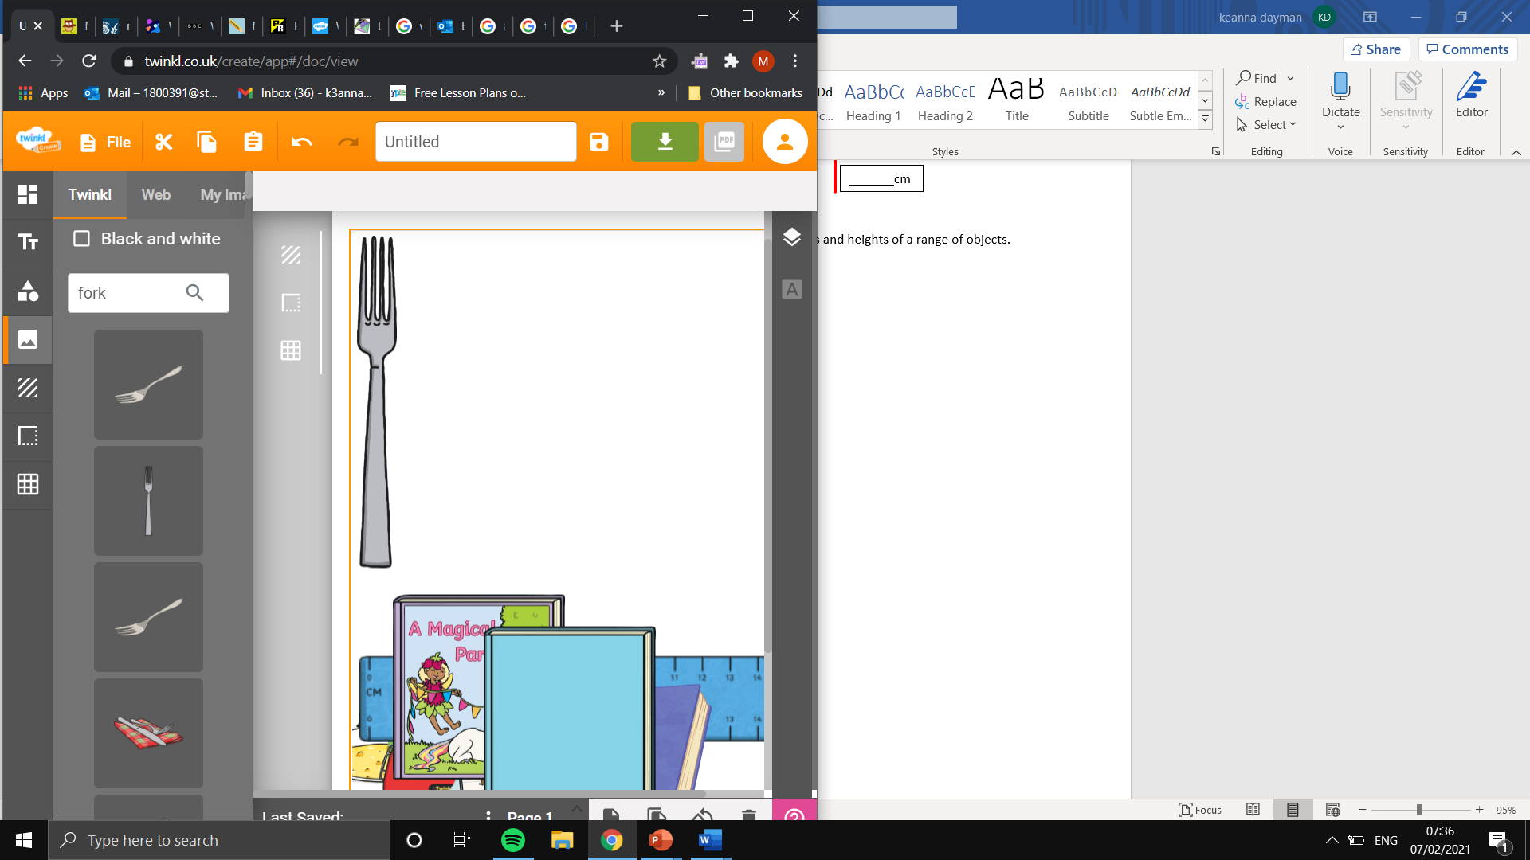
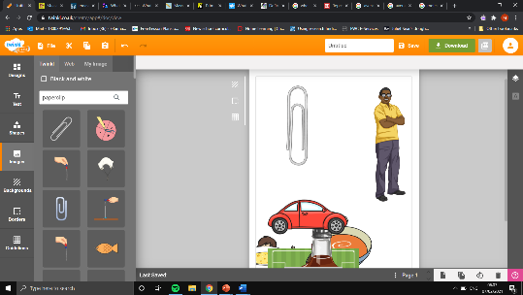
Task: using the measured objects below, estimate the lengths and heights of a range of objects.
Estimated paperclip height: 3.5cm.
Estimated height of a pug in standard units of measurement: 24.3cm
Calculations: 7 x 3.5
Estimated paperclip height: 3.5cm.
Estimated height of a fork in standard units of measurement:
21 cm
Calculations: 6 x 3.5
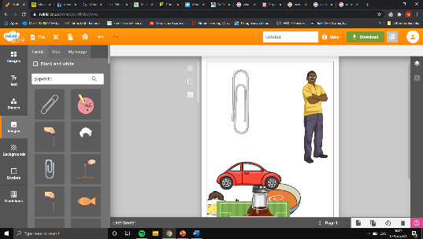
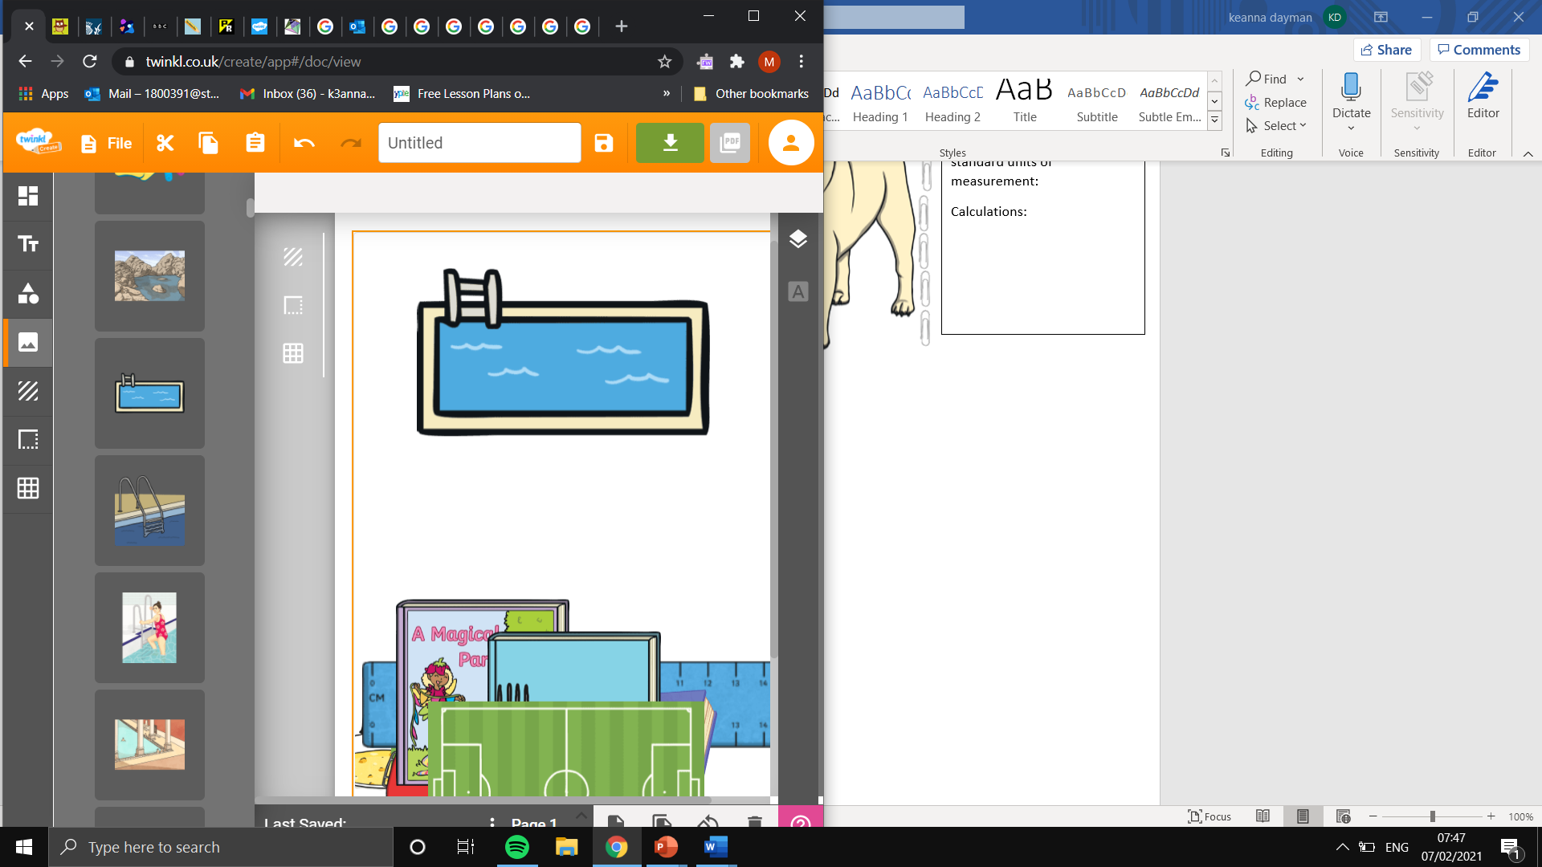
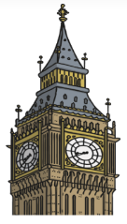
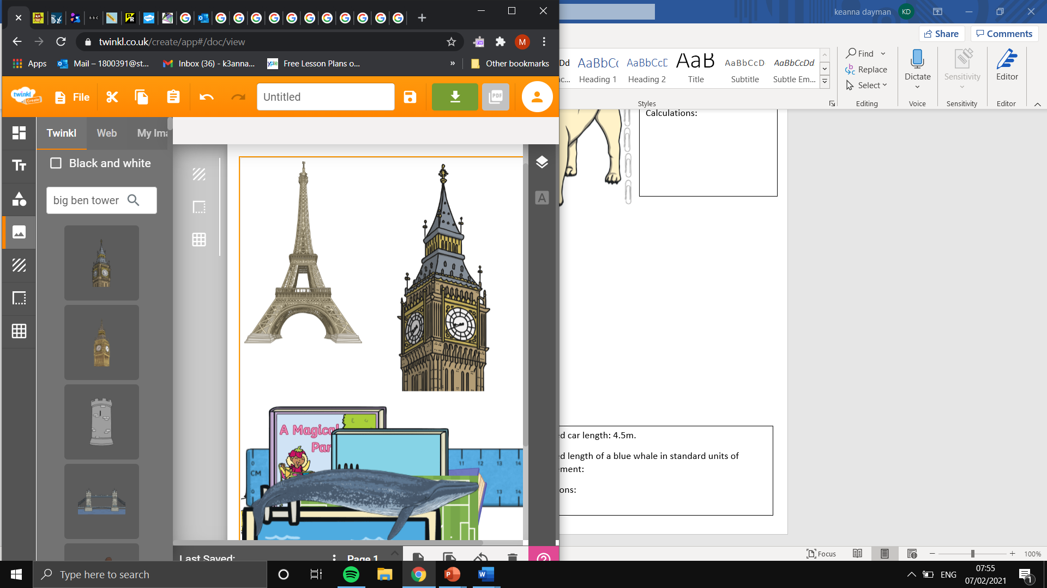
Estimated height of big Ben: 100m.
Estimated height of the Eiffel Tower in standard units of measurement:
300m
Calculations:
3 x 100

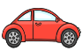
Estimated car length: 4.5m.
Estimated pool length in standard units of measurement: 45m
Calculations: 10 x 4.5

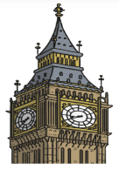

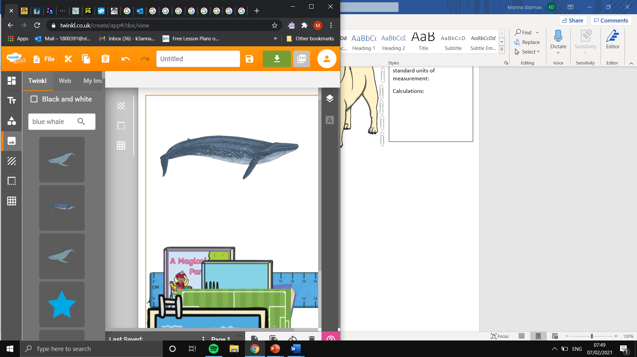
Estimated car length: 4.5m.
Estimated length of a blue whale in standard units of measurement:31.5m
Calculations: 7 x 4.5



