Estimating lengths

Learning Objectives: to estimate and measure length using appropriate standard units.
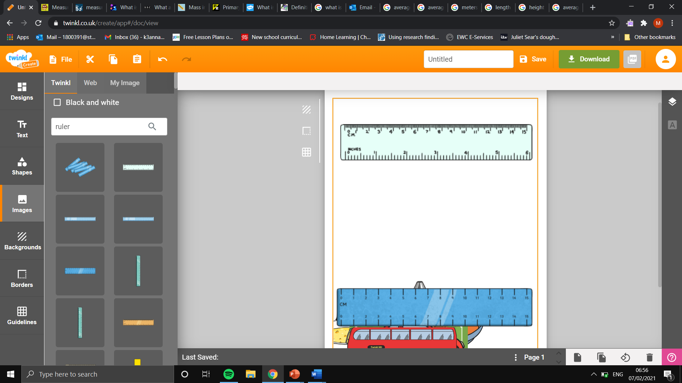
Task: using the ruler, estimate the measurement on the ruler in centimetres.

10.6 cm
6.0C m
2.1 cm

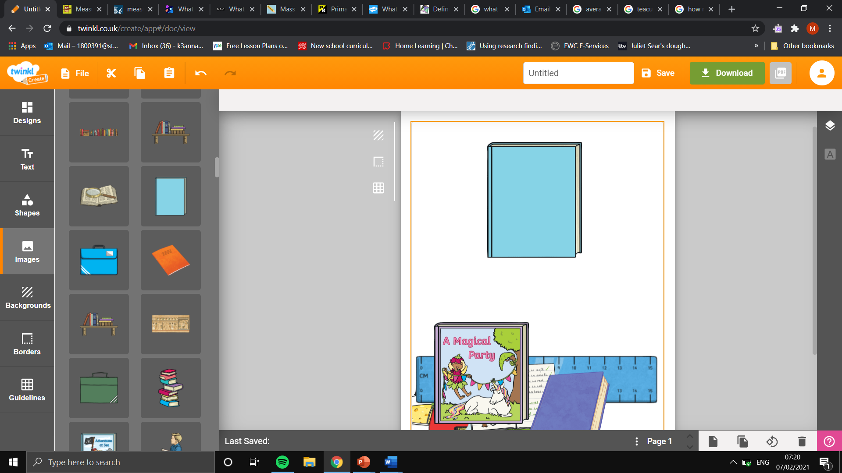
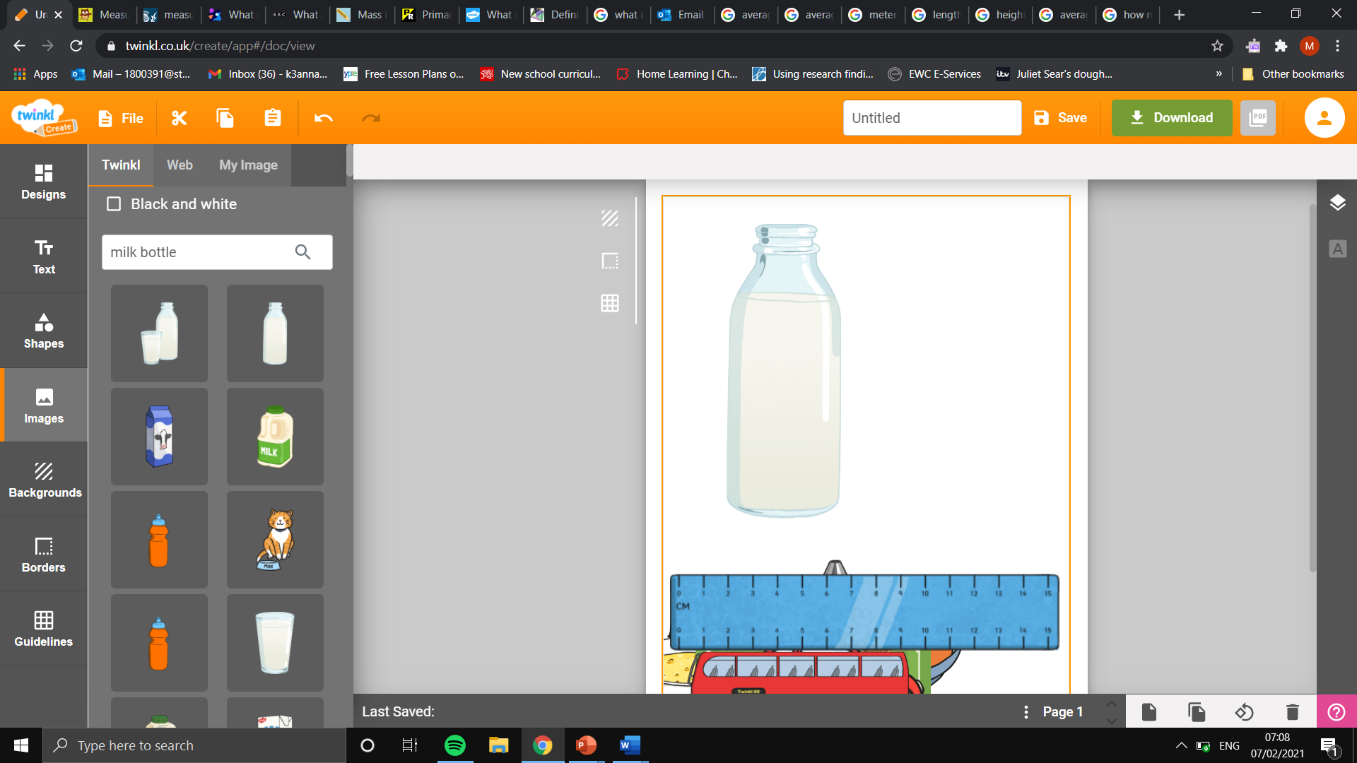
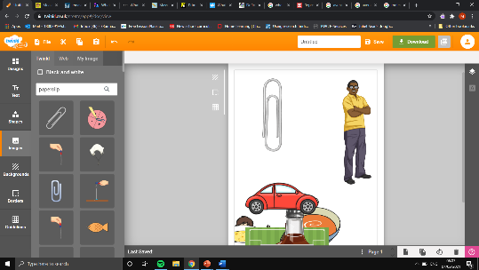
Task: using the measured objects below, estimate the lengths and heights of a range of objects.
Estimated paperclip height: 3.5cm.
Estimated height of a bottle of milk in standard units of measurement: 17.5 cm
Calculations: 5 x 3.5
Estimated paperclip length: 3.5cm.
Estimated length of a book in standard units of measurement:21 cm
Calculations: 6 x 3.5

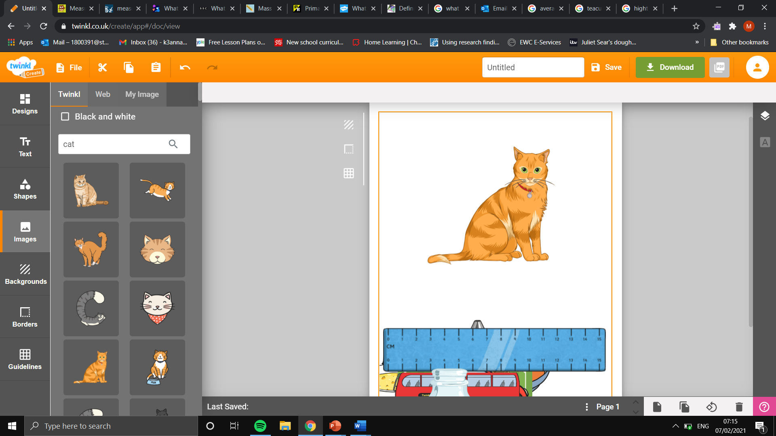
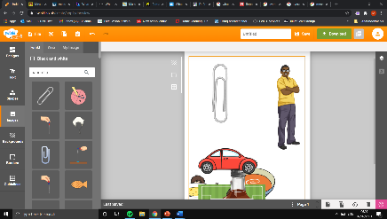
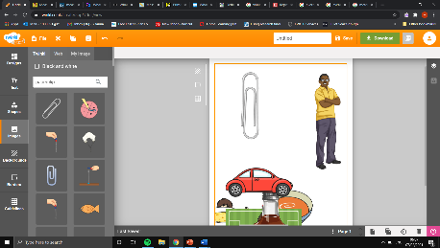
Estimated paperclip height: 3.5cm.
Estimated height of a cat in standard units of measurement:
24.5 cm
Calculations: 7 x 3.5
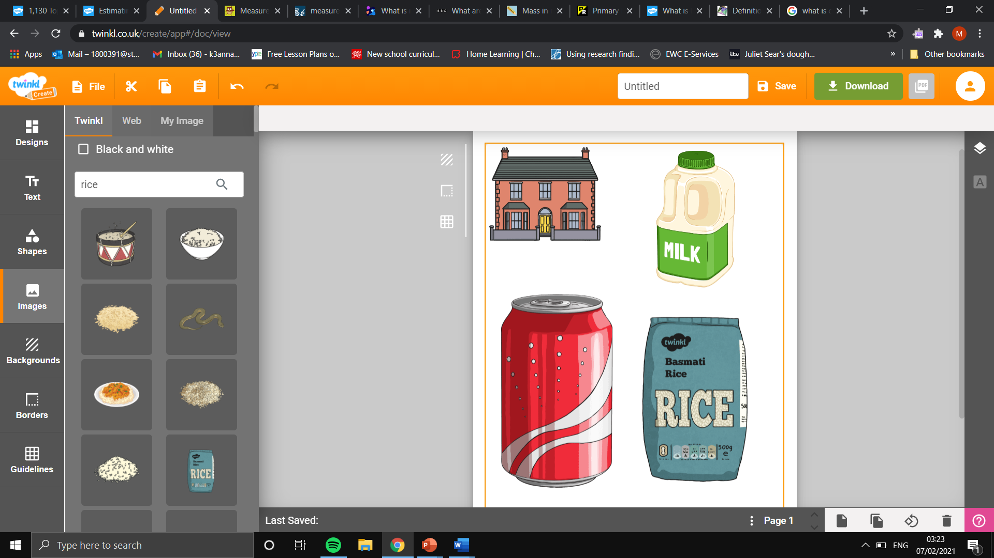
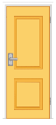

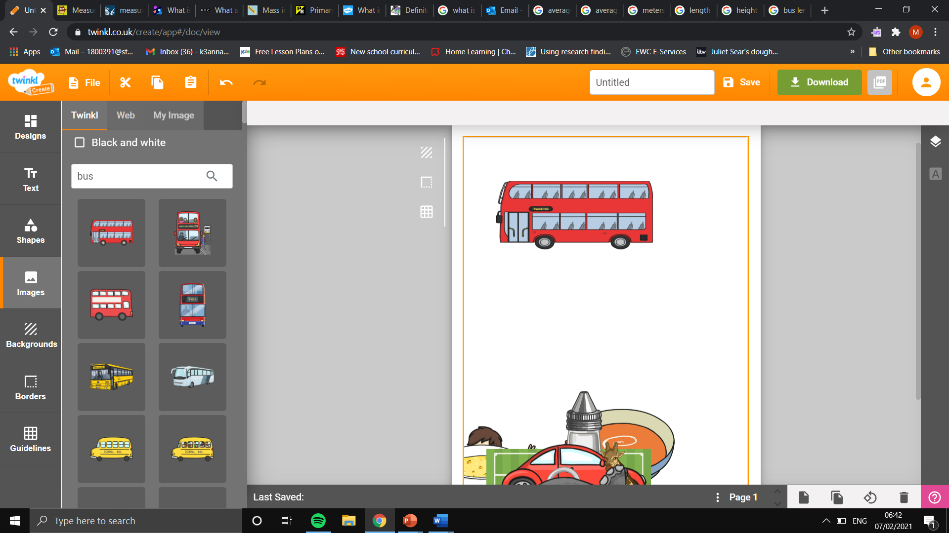
Estimated door height: 2m.
Estimated house height in standard units of measurement: 6m
Calculations: 2 x 3

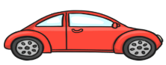
Estimated car length: 4.5m.
Estimated bus length in standard units of measurement:18m
Calculations: 4.5 x 4

