Estimating lengths

Learning Objectives: to estimate and measure length using appropriate standard units.
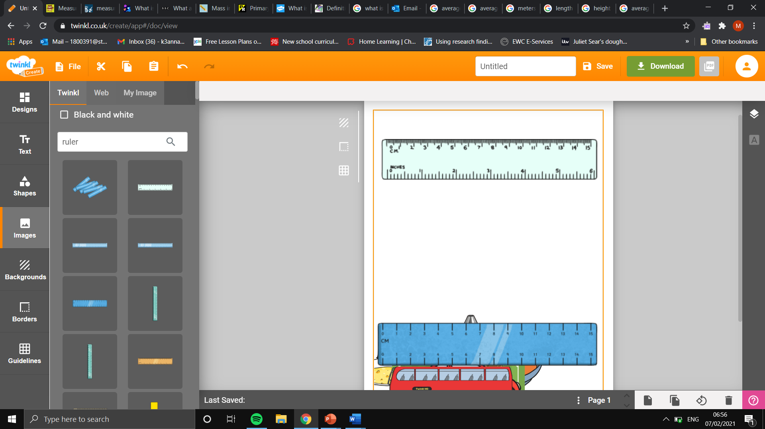
Task: using the ruler, estimate the measurement on the ruler in centimetres.

2.5 cm
7.0 cm
12.5cm

Task: using the measured objects below, estimate the lengths and heights of a range of objects.
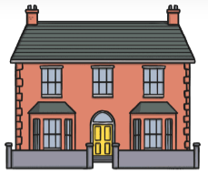
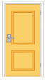
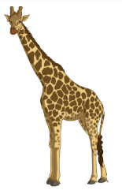
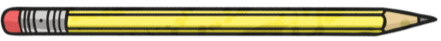
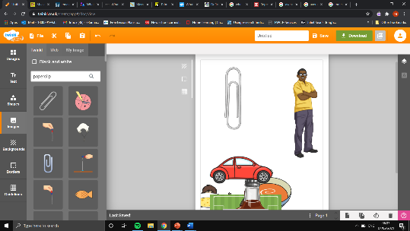
Estimated door height: 2m.
Estimated house height in standard units of measurement:6m
Calculations: 3 x 2
Estimated door height: 2m.
Estimated height of the giraffe in standard units of measurement: 4m
Calculations: 2 x 2
Estimated paperclip length: 3.5cm.
Estimated height of the giraffe in standard units of measurement:
17.5cm
Calculations: 3.5 x 5

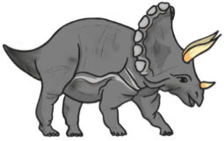
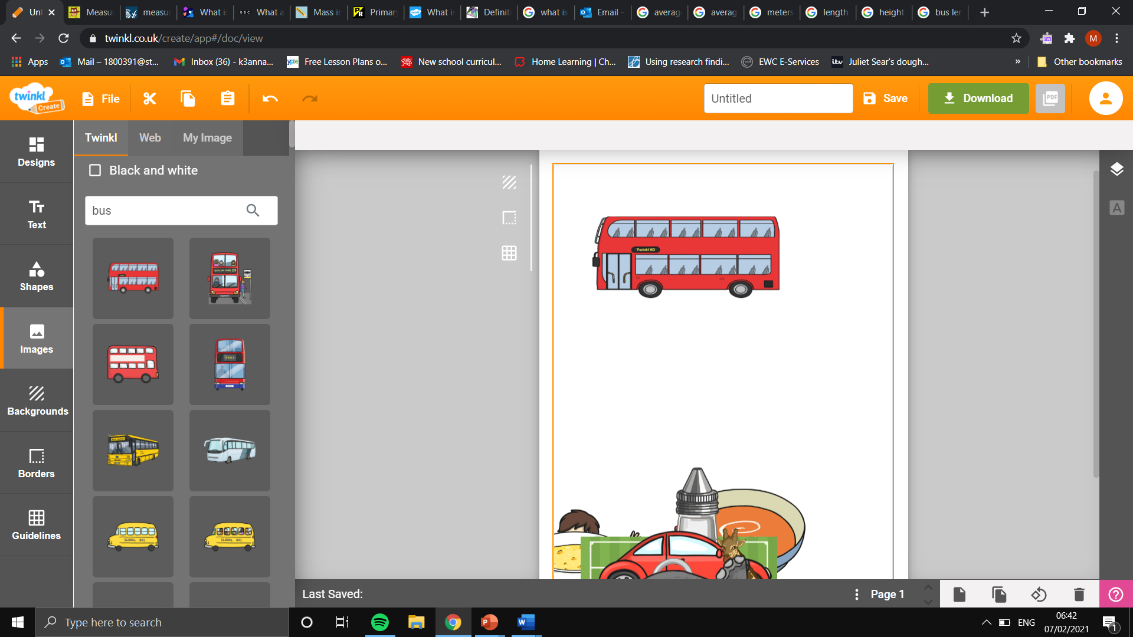

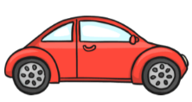
Estimated car length: 4.5m.
Estimated triceratops length in standard units of measurement:9m
Calculations: 2 x 4.5
Estimated car length: 4.5m.
Estimated bus length in standard units of measurement:
18m
Calculations: 4.5 x 4

