Measuring Time and Temperature

Learning Objective: To estimate and measure time and temperature using appropriate standard units.
Susie bought an ice cream every day for a week. She timed how long her ice cream took to melt each day. Each day of the week had a different temperature. Measure the time and temperature to fill in the missing measurements in the table.

Day 6: Saturday
Day 5: Friday
Day 4: Thursday
Day 3: Wednesday
Day 2: Tuesday
Day 7: Sunday
Day 1: Monday
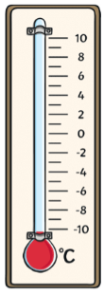
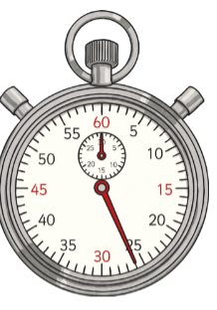
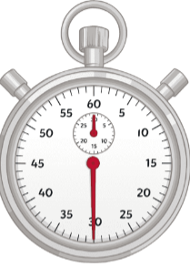
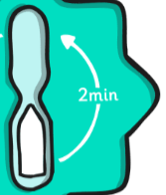
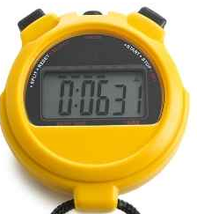
==
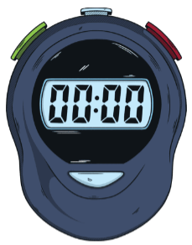
M S
04:00
01:30
01:00

Day of the week | Monday | Tuesday |  | Thursday | Friday |  | Sunday
Temperature (°C) | 10 °C | 6°C |  |  |  | 2°C
Time  second(S)/ minute(M)/ hour(H) | 26 seconds |  | 1 minute |  | 2 minutes |  | 6 minutes  31 seconds

