Measuring Time and Temperature

Learning Objective: To estimate and measure time and temperature using appropriate standard units.
Task: using Wales as your start time, calculate the times for the other countries. Moreover, measure the temperatures using the appropriate units of measure.
Madrid, Spain
Canberra, Australia
Ushuaia,
Antarctica
Vancouver, Canada
Mexico City, Mexico

New York, America

Swansea, Wales
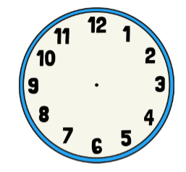

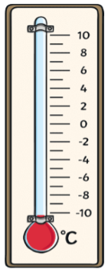
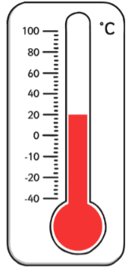
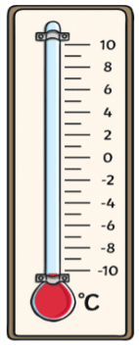
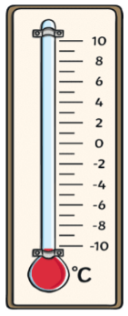
Add 21 °C to Antarctica to find out Canada’s temperature.
Five times the temperature in Wales.
The temperature is the same as Spain but add 2 °C

Country,  City | Vancouver,  Canada | Mexico City,  Mexico | New York, America | Swansea,  Wales | Madrid,  Spain | Canberra, Australia | Ushuaia,  Antarctica
Time zone | - 8 hours | - 6 hours | - 5 hours | 0 hours | + 1 hours | + 11 hours | + 13 hours
Time |  |  |  | 5:00
Temperature |  |  |  | 5 °C

