Remember
1 cm. = 10 mm (Multiply by 10)
1m = 100 cm (Multiply by 100)

Converting Measurements – Green Task

- 5cm = mm

- 7cm = mm

- 9cm = mm

- 10 cm = mm

- 17 cm = mm

- 23 cm = mm

- 28 cm = mm

- 2 m = cm

- 6 m = cm

- 9 m = cm

- 12 m = cm

- 15 m = cm

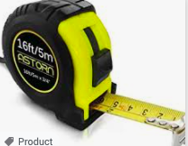
- 22cm = mm

- 18m = cm

- 35 cm = mm

- 21 m = cm

