Mass and Capacity

Learning Objective: To estimate and measure mass and capacity using appropriate standard units.
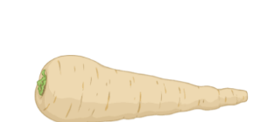
Task: Measure the number of millilitres, litres, grams, or kilograms using each method of measurement.
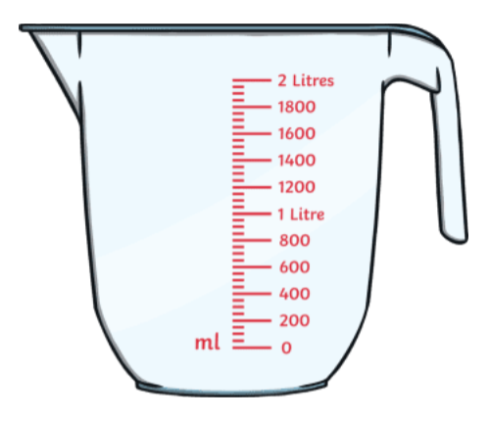
Method of measurement:
Measuring jug
Unit of measurement: ml/L
Measurement: 600ml
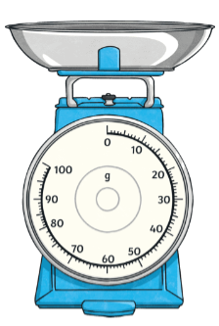
Method of measurement:
Kitchen Scale
Unit of measurement:
g/ Kg
Measurement: 30g

Method of measurement:
Measuring jug
Unit of measurement: ml/L
Measurement: 200ml

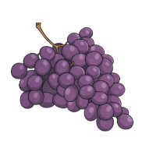
Method of measurement:
Kitchen Scale
Unit of measurement:
g/ Kg
Measurement: 95g
Method of measurement:
Measuring jug
Unit of measurement: ml/L
Measurement: 800ml

Method of measurement:
Measuring jug
Unit of measurement: ml/L
Measurement: 400ml

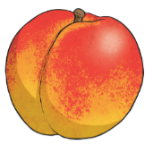

Method of measurement:
Kitchen Scale
Unit of measurement:
g/ Kg
Measurement: 100g
Method of measurement:
Measuring jug
Unit of measurement: ml/L
Measurement: 250ml

Mass and Capacity

Learning Objective: To estimate and measure mass and capacity using appropriate standard units.
Task: Measure the number of millilitres, litres, grams or kilograms using each method of measurement.
Method of measurement:
Kitchen Scale
Unit of measurement:
g/ Kg
Measurement: 50g
Method of measurement:
Measuring jug
Unit of measurement: ml/L
Measurement: 800ml

Method of measurement:
Measuring jug
Unit of measurement: ml/L
Measurement: L= 1L
ml= 1000ml

Method of measurement:
Kitchen Scale
Unit of measurement:
g/ Kg
Measurement: 350g
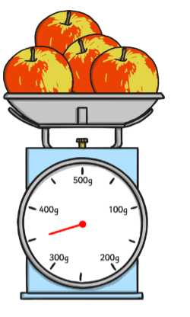
Method of measurement:
Measuring jug
Unit of measurement: ml/L
Measurement: 750ml

Method of measurement:
Measuring jug
Unit of measurement: ml/L
Measurement: 900ml

Method of measurement:
Kitchen Scale
Unit of measurement:
g/ Kg
Measurement: 330g
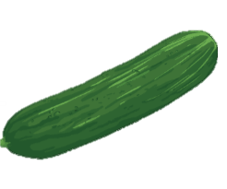
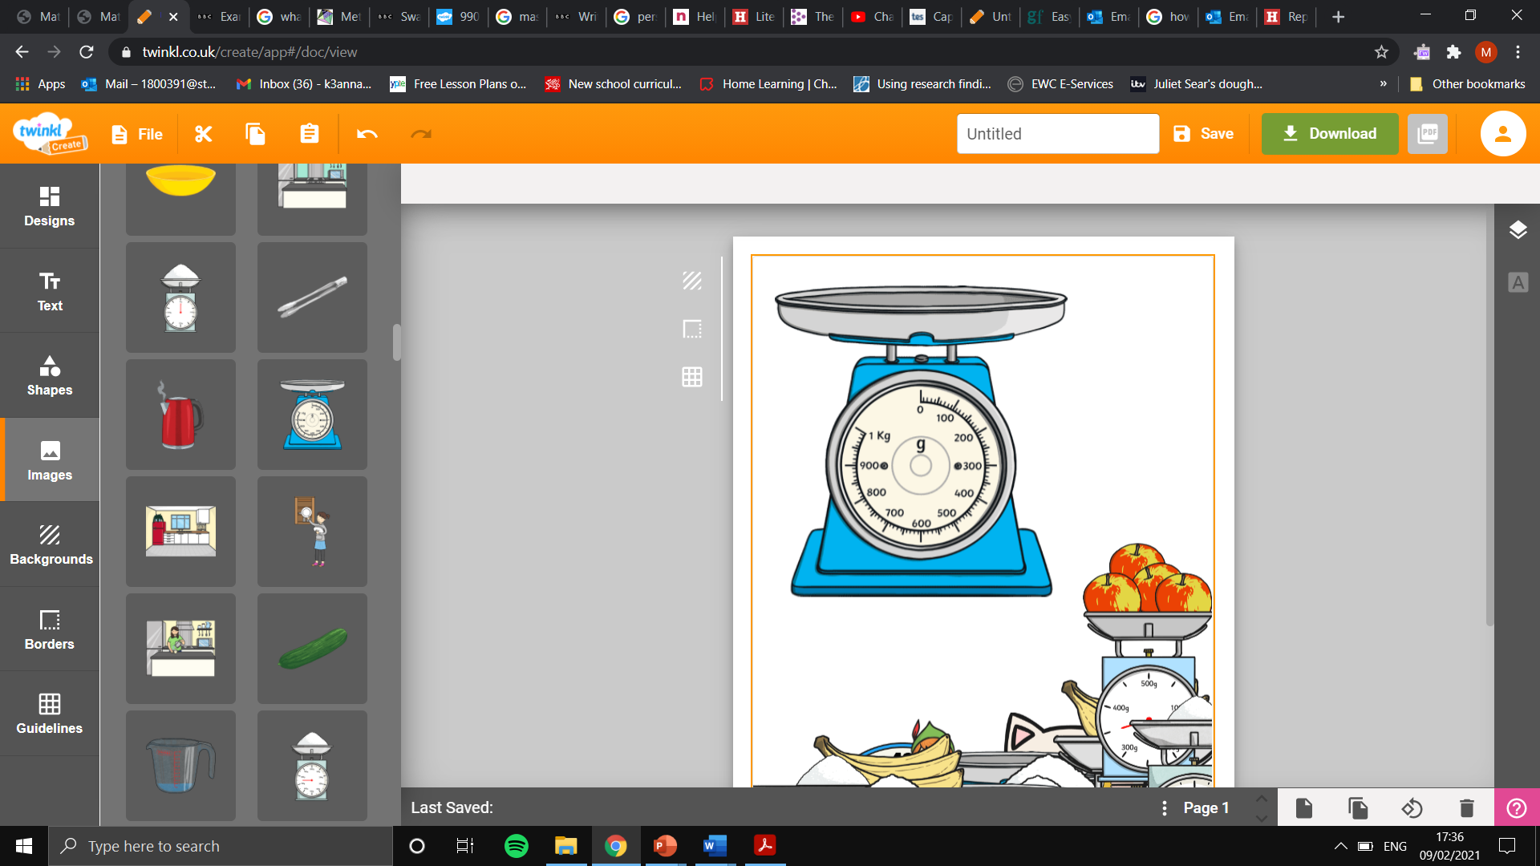
Method of measurement:
Measuring jug
Unit of measurement: ml/L
Measurement: 250ml

Mass and Capacity

Learning Objective: To estimate and measure mass and capacity using appropriate standard units.
Task: Measure the number of millilitres, litres, grams or kilograms using each method of measurement.
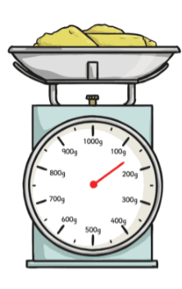
Method of measurement:
Measuring jug
Unit of measurement: ml/L
Measurement:
L=1.4L ml=1400ml
Method of measurement:
Kitchen Scale
Unit of measurement:
g/ Kg
Measurement: 150g

Method of measurement:
Measuring jug
Unit of measurement: ml/L
Measurement:
L= 2L ml= 2000ml

Method of measurement:
Kitchen Scale
Unit of measurement:
g/ Kg
Measurement: 990g
Method of measurement:
Measuring jug
Unit of measurement: ml/L
Measurement:
L= 1.95L ml= 1950ml

Method of measurement:
Measuring jug
Unit of measurement: ml/L
Measurement:
L=1.75L ml= 1750ml

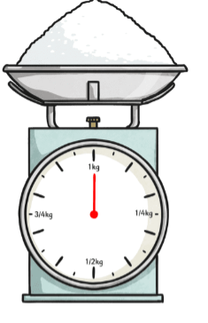
Method of measurement:
Kitchen Scale
Unit of measurement:
g/ Kg
Measurement:
Kg= 1Kg
g= 1000g
Method of measurement:
Measuring jug
Unit of measurement: ml/L
Measurement:
L=0.8 L
ml= 800ml

