Measuring Time and Temperature

Learning Objective: To estimate and measure time and temperature using appropriate standard units.
Susie bought an ice cream every day for a week. She timed how long her ice cream took to melt each day. Each day of the week had a different temperature. Measure the time and temperature to fill in the missing measurements in the table.

Day 6: Saturday
Day 5: Friday
Day 4: Thursday
Day 3: Wednesday
Day 2: Tuesday
Day 7: Sunday
Day 1: Monday
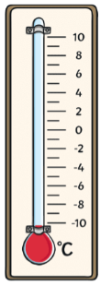
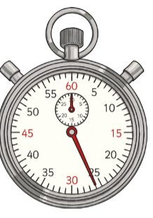
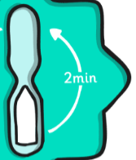
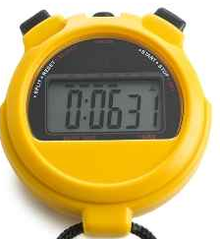
==
2 degrees less than day 3.
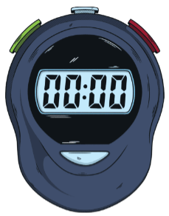
Double the time of day 5.
Double the time of day 1.
M S
01:30
01:00

Day of the week | Monday | Tuesday | Wednesday | Thursday | Friday | Saturday | Sunday
Temperature (°C) | 10 °C | 6°C | 5°C | 3°C | 3°C | 1°C | 1°C
Time  second(S)/ minute(M)/ hour(H) | 26 seconds | 52 seconds | 1 minute | 1 minutes  30 seconds | 2 minutes | 4 minutes | 6 minutes  31 seconds

