REMEMBER
1 cm. = 10 mm (Multiply by 10)
1m = 100 cm (Multiply by 100)

Converting Measurements – AMBER Task
- 5cm = 50 mm

- 7cm = 70 mm

- 23 cm = 230 mm

- 28 cm = 280 mm

- 2 m = 200 cm

- 8 m = 800 cm

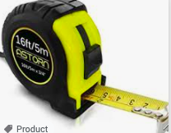
- 22cm = 220 mm

- 18m = 1800 cm

- 35 cm = 350 mm

- 21 m = 2100 cm

- 2.3 cm = 23 mm

- 8.4 cm = 84 mm

- 13.5 cm = 135 mm

- 2.7m = 270 cm

- 8.3 m = 830 cm

- 12.1 cm = 210 mm

- 18.2 m = 1820 cm

