Remember
1 cm. = 10 mm (Multiply by 10)
1m = 100 cm (Multiply by 100)

Converting Measurements – Green Task

- 5cm = 50 mm

- 7cm = 70 mm

- 9cm = 90 mm

- 10 cm = 100 mm

- 17 cm = 170 mm

- 23 cm = 230 mm

- 28 cm = 280 mm

- 2 m = 200 cm

- 6 m = 600 cm

- 9 m = 900 cm

- 12 m = 1200 cm

- 15 m = 1500 cm

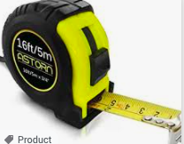
- 22cm = 220 mm

- 18m = 1800 cm

- 35 cm = 350 mm

- 21 m = 2100 cm

