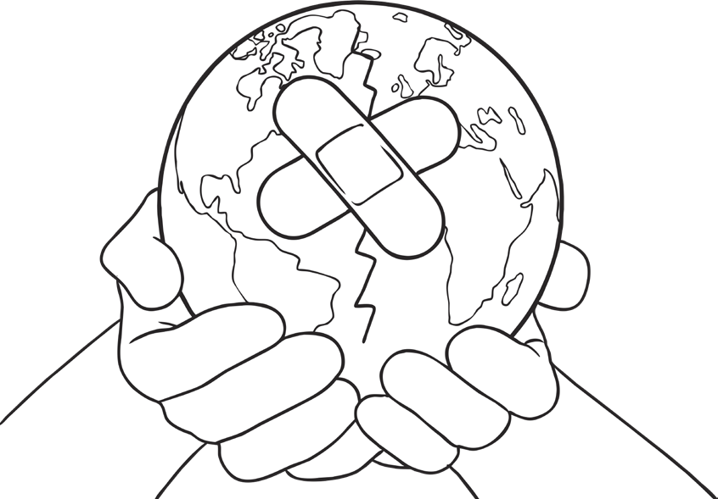
3 Ways I Can Help Our Earth

