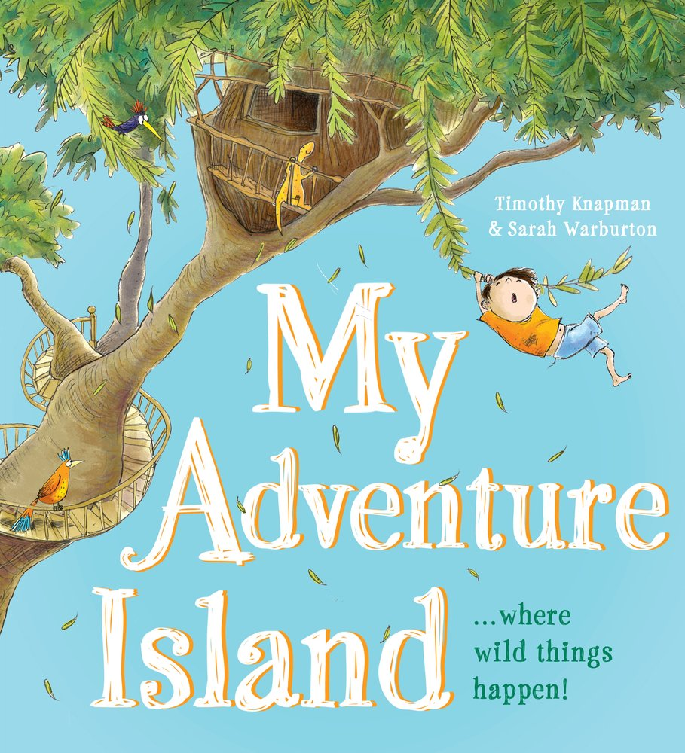

We will stop reading half way through.
What you would do on your own island?
Use your imagination to write or draw your ideas.

