Function Machines

Learning Objective: To develop my use of function machines to understand input and output including the use of inverse operations.
Task: complete the function machines to find the inputs and outputs using addition, subtraction, multiplication, and division.

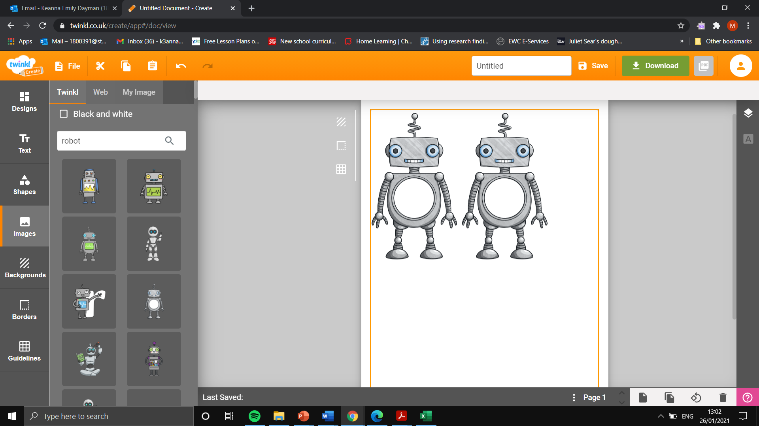
Addition and subtraction (1 step)
Input
78
Input
40
Output

Rule- 32
Output
54
Input

Input
20
Output

Input
18
Rule+ 63
Input

Output
95
Input

Multiplication and division
Input
9
Input
3
Output

Input

Rulex3
Addition and subtraction (2 step)

Output

Output

Rule
- 29
Rule
+ 13

Output
30

Output

Output

Output
18
Input
60

Output

Input
100
Rule X5
Input
18
Output

Rule $÷3$

Rule$÷4$
Output
40

Input

Input
30

Output

