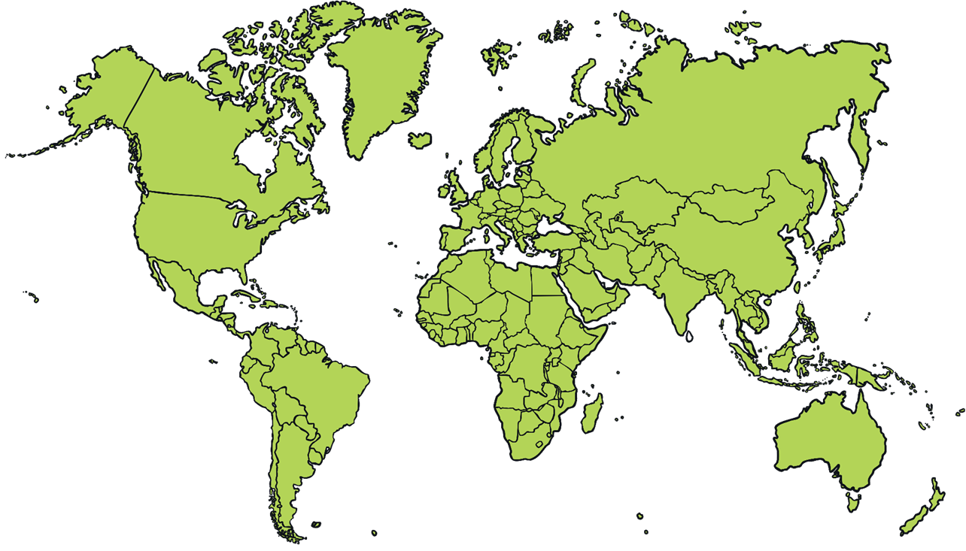

With an adult, find, label and name 5 different countries.
Ask an adult for help to use an Atlas or Google research together.

