Task: Can you design a Christmas jumper for Fflic or Fflac on your Hwb account?

Go on your HWB account and go onto :

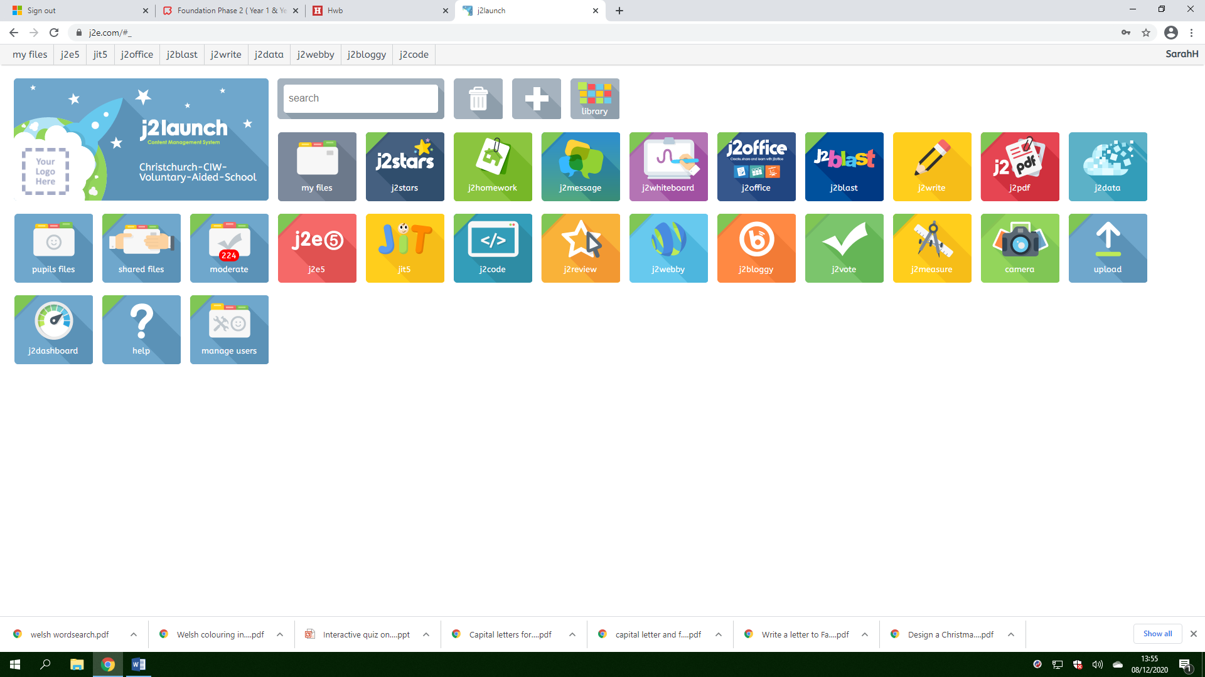
Click onto JIT
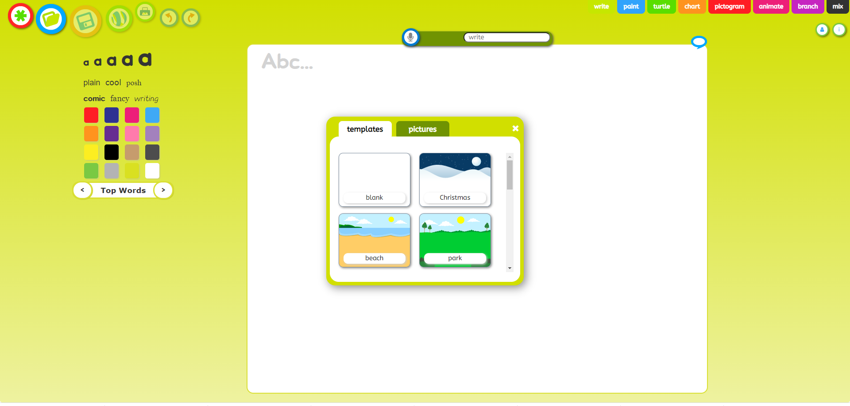

Click on the blue paint tab and get creative!

