Function Machines

Learning Objective: To develop my use of function machines to understand input and output including the use of inverse operations.
Task: complete the function machines to find the inputs and outputs using addition, subtraction, multiplication, and division.

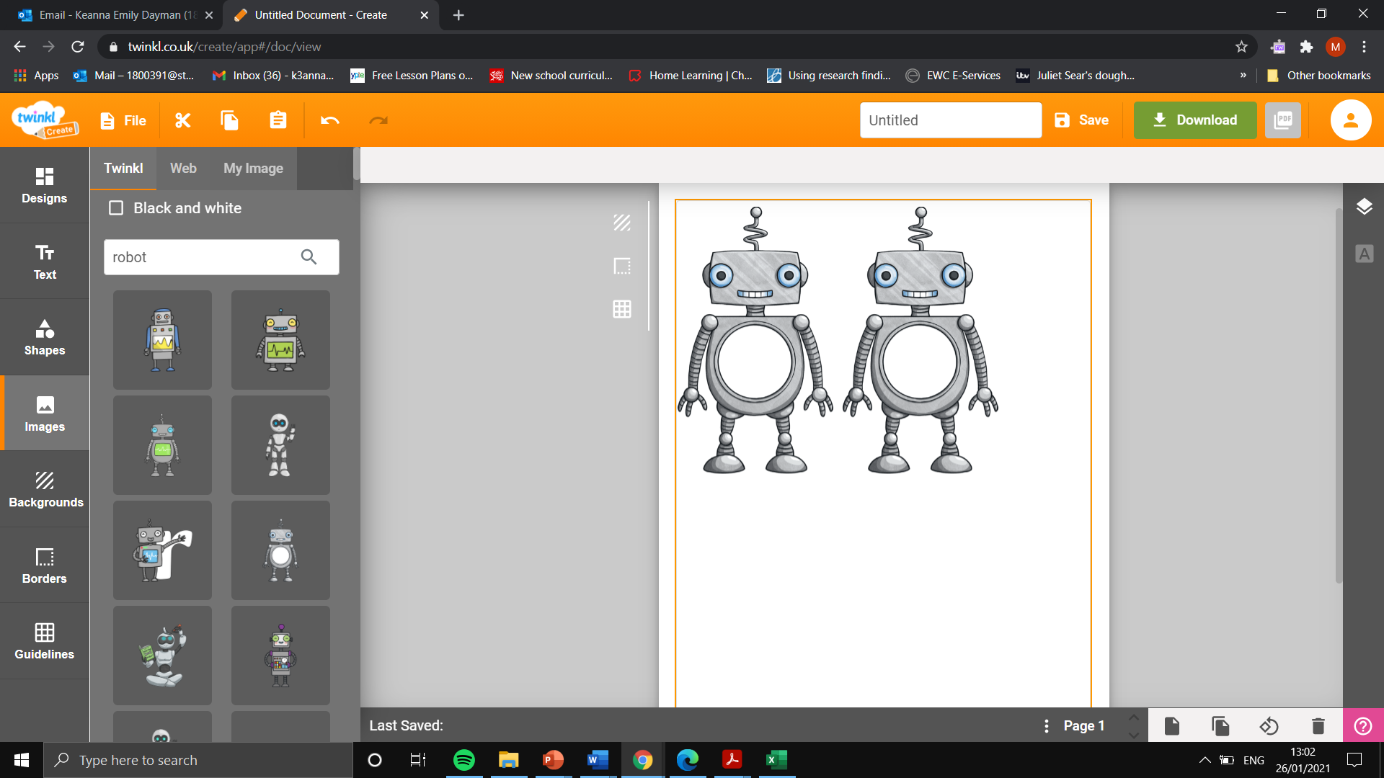
Addition and subtraction (1 step)
Input
78
Input
40
Output
46
Rule- 32
Output
54
Input
86

Input
20
Output
81
Input
18
Rule+ 63
Input
32
Output
95
Input
14

Multiplication and division
Input
9
Input
3
Output
9
Input
6

Rulex3
Addition and subtraction (2 step)

Output
14

Output
4

Rule
- 29
Rule
+ 13

Output
30

Output
15

Output
100

Output
18
Input
60

Output
25
Input
100
Rule X5
Input
18
Output
30
Rule $÷3$

Rule$÷4$
Output
40

Input
10
Input
30

Output
50

