Function Machines

Learning Objective: To develop my use of function machines to understand input and output including the use of inverse operations.
Task: complete the function machines to find the inputs and outputs using addition, subtraction, multiplication, and division.

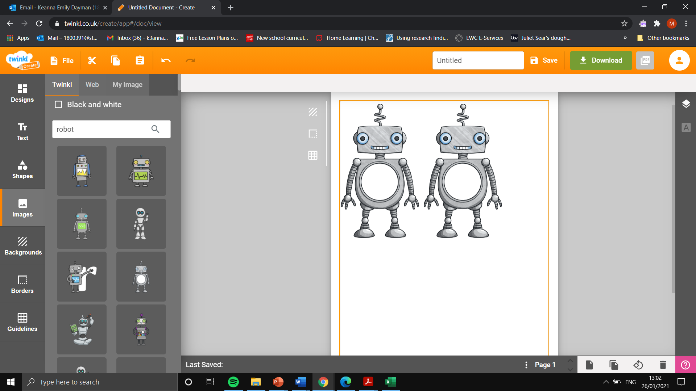
Addition and subtraction (1 step)
Input
50
Input
20
Output
30
Rule- 20
Output
45
Input
65

Input
31
Output
68
Input
54
Rule+ 14
Input
46
Input
1
Output
15

Multiplication and division
Input
3
Input
8
Output
15
Addition and subtraction (2 step)

Output
4

Output
15

Rule
- 25
Rule
+ 9

Output
30

Output
12
Output
4
Input
4

Input
2

Output
25
Input
3
Input
50
Output
10
Output
9
Rule $÷2$
Rule
X3
Rulex5

Input
10
Input
10
Output
50

Input
100
Output
50
Output
30

