Spring Term Home Learning Day 1

Video

Can you join in with the Singing Walrus to practice counting to 100?

https://www.youtube.com/watch?v=Fe9bnYRzFvk

Challenge yourself

Can you practice counting back from:

10, 20 and 30 in 1’s

Example
10, 9, 8, 7, 6, 5, 4, 3, 2, 1
20, 19, 18, 17, 16,

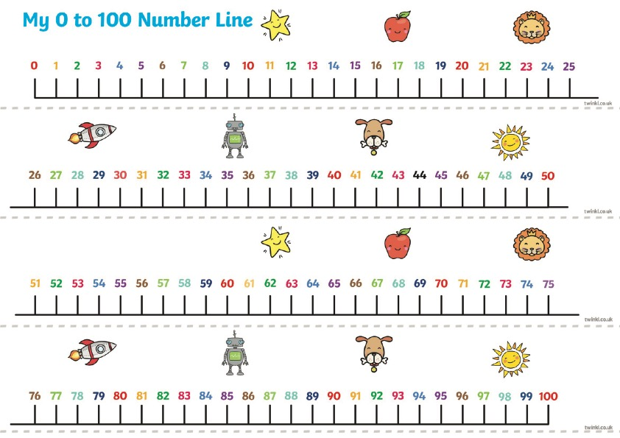
Some maths songs to help you with your counting

https://www.bbc.co.uk/cbeebies/watch/number-songs-from-numberblocks

Some maths games to help you with your counting

https://www.ictgames.com/mobilePage/whackAMole/index.html

https://www.topmarks.co.uk/learning-to-count/chopper-squad

