Revision week
Monday 8th February 2021
GREEN Challenge
Data, addition and temperature
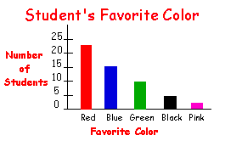  How many students liked the colour blue?  Can you collect data from your family, on what their favourite colours are? | Can you answer these addition number sentences?  - 5 + 3 =  - 9 + 1 =  - 6 + 4 =  - 1 + 3 =  - 8 + 2 = | What unit of measure do we use for temperature?  What temperature is showing on this thermometer?  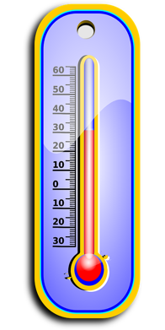
Looking at the bar graph above.  How many more children like blue than green? | Can you remember your number bonds to 10?  1 + ? = 10  5 + ? = 10  8 + ? = 10  10+ ? = 10 | Which temperature is hotter?  15°C Or 20°C  Put a circle around your answer.
Revision week
Monday 8th February 2021
YELLOW Challenge
Data, addition and temperature
How many children like black?  Can you collect data from your family, on what their favourite colours are? | Can you answer these addition number sentences?  - 15 + 3 =  - 19 + 1 =  - 16 + 4 =  - 11 + 3 =  - 18 + 2 = | What unit of measure do we use for temperature?  What temperature is showing on this thermometer?  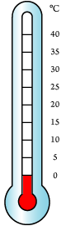
Looking at the bar graph above.  Do more children like blue than black?  How many more? | Can you remember your number bonds to 10?  1 + ? = 10  5 + ? = 10  8 + ? = 10  10+ ? = 10 | Which temperature is hotter?  0°C Or 20°C  Put a circle around your answer.
Revision week
Monday 8th February 2021
Red Challenge
Data, addition and temperature
Can you tell me how many children like red?  Can you collect data from your family, on what their favourite colours are? | Can you answer these addition number sentences?  1. 25 + 3 =  2. 29 + 1 =  3. 26 + 4 =  4. 21 + 3 =  5. 28 + 2 = | What unit of measure do we use for temperature?  Can you show me where 9°C would be?  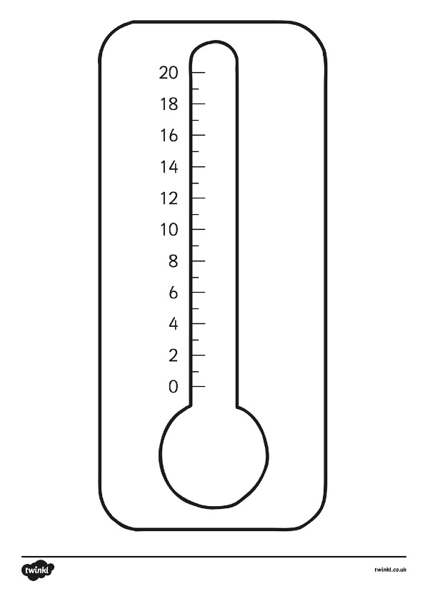
Looking at the bar graph above.  Do more children like red than pink?  How many more children like red than pink? | Can you remember your number bonds to 20?  1 + ? = 20  5 + ? = 20  8 + ? = 20  10+ ? = 20 | Which temperature is hotter?  15°C Or -15°C  Put a circle around your answer.

