Date handed out:2nd October 2020
Dear Parents,
We have had another brilliant week in FP2. This week we have been writing a recount, adding numbers and we painted our clay portraits. Your child’s HWB password and username is in the front of their homework book. Homework will continue to be in the book but we wanted you to be able to access HWB at home for you to have a go and build confidence in your free time.
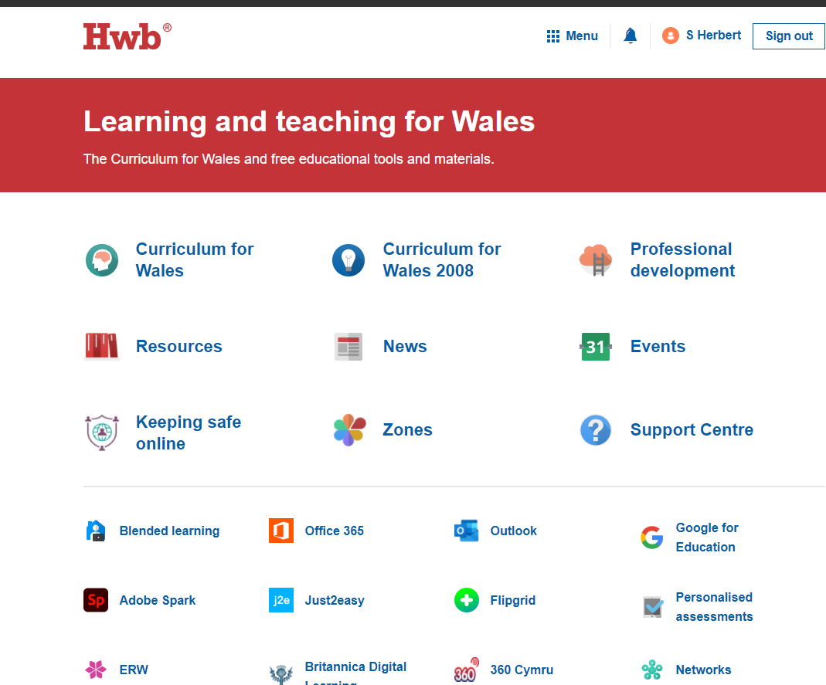
1. Log onto HWB. https://hwb.gov.wales/
2. Click on J2e icon. This will take you to the page to click on further activities.
3. Click on JIT and it will take you to a page where you can type,paint and create data like we do in the classroom.
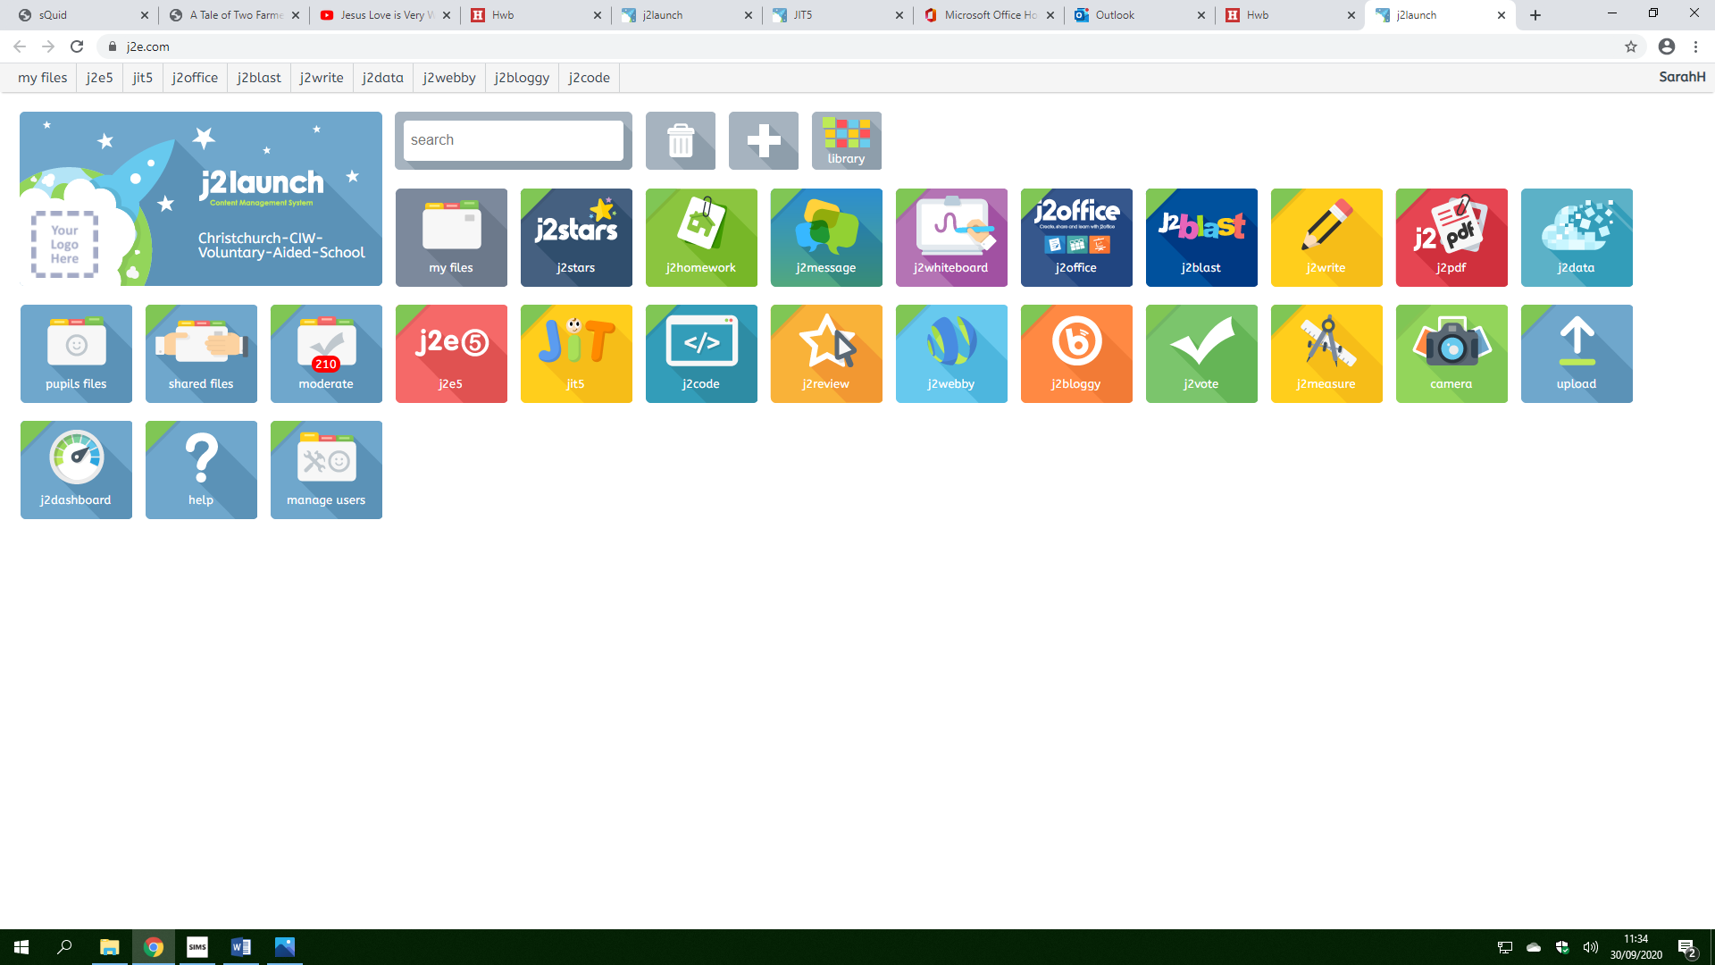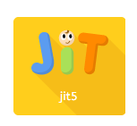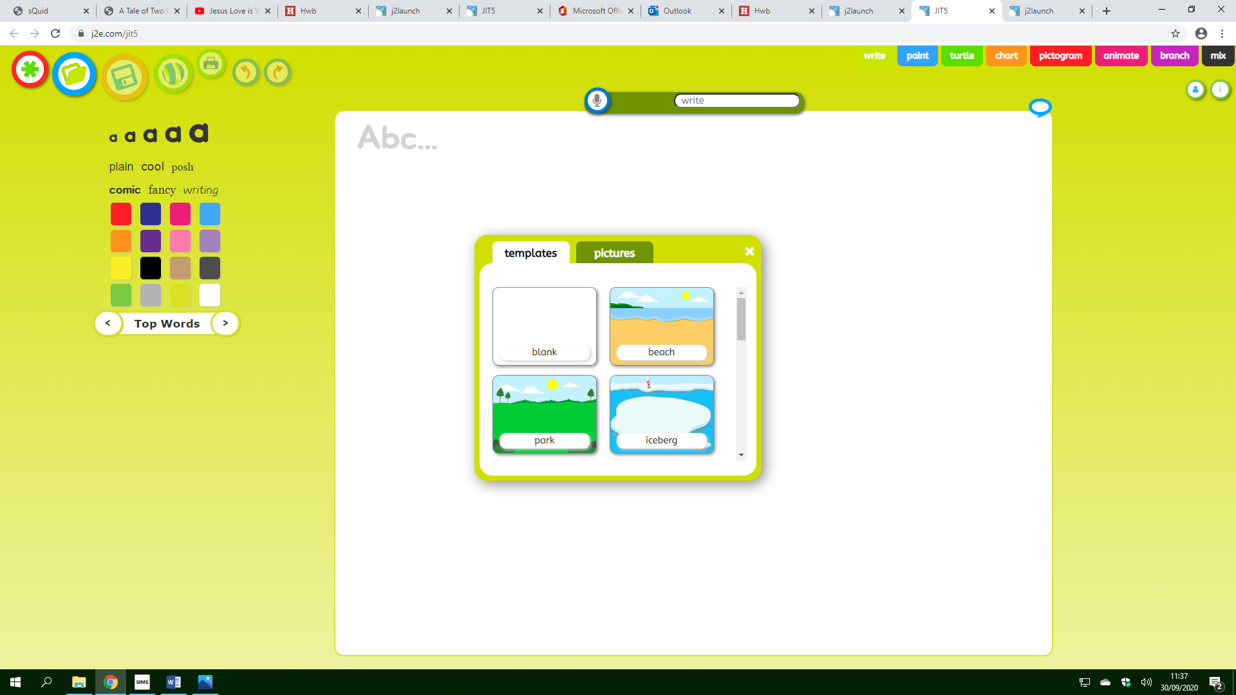
Reminders
- Please write a comment on your child’s homework to let us know how well your child completed the work.
- Visit www.christchurchpri.co.uk for up to date news and school letters.
HOMEWORK
Literacy – In class, we have been writing RECOUNTS. We have been using the sentence starters: Firstly, Next, Later and Finally. Can you write and draw what you got up to on the weekend. You can use your imagination and pretend you went somewhere like the moon.
Maths –

Have a lovely weekend,
Miss Herbert and the FP2 team.

Literacy 02.10.20 – In class, we have been writing RECOUNTS. We have been using the sentence starters: Firstly, Next, Later and Finally. Can you write and draw what you got up to on the weekend. You can use your imagination and pretend you went somewhere like the moon.

Literacy 02.10.20 – In class, we have been writing RECOUNTS. We have been using the sentence starters: Firstly, Next, Later and Finally. Can you write and draw what you got up to on the weekend. You can use your imagination and pretend you went somewhere like the moon.

Literacy 02.10.20 – In class, we have been writing RECOUNTS. We have been using the sentence starters: Firstly, Next, Later and Finally. Can you write and draw what you got up to on the weekend. You can use your imagination and pretend you went somewhere like the moon.

Literacy 02.10.20 – In class, we have been writing RECOUNTS. We have been using the sentence starters: Firstly, Next, Later and Finally. Can you write and draw what you got up to on the weekend. You can use your imagination and pretend you went somewhere like the moon.

Literacy 02.10.20 – In class, we have been writing RECOUNTS. We have been using the sentence starters: Firstly, Next, Later and Finally. Can you write and draw what you got up to on the weekend. You can use your imagination and pretend you went somewhere like the moon.

