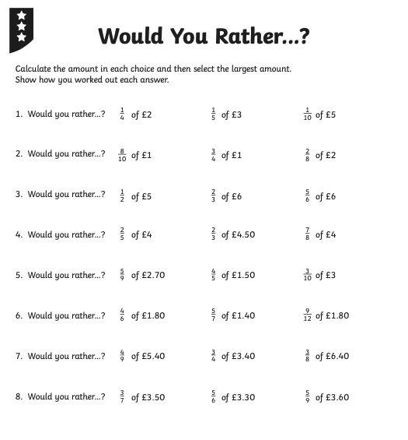
Remember you can convert £ into P. eg £2.00 = 200p. 200÷4 = 50 so 50p

=50p
5=50p
=60p
= 50p

REMEMBER USE A CALCULATOR!

