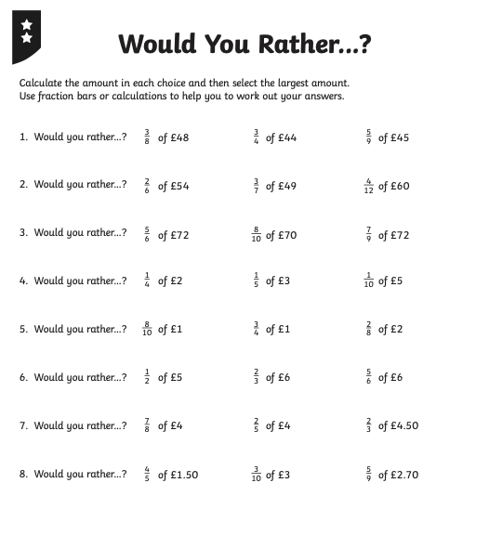
=£25
5

= £33
= £18
REMEMBER USE A CALCULATOR!

