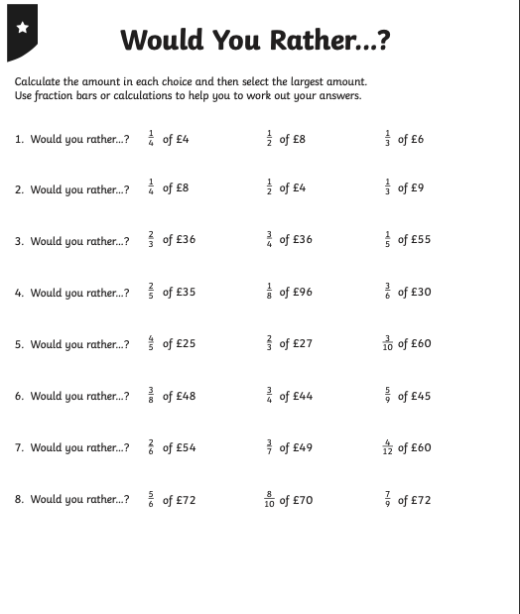
W

=£2
=£4
=£1
REMEMBER USE A CALCULATOR!

