Peace Mala International Interfaith Liturgy for World Peace at
Saint Mary’s Minster in Swansea Wales UK

Celebrating the United Nations International Day of Peace in
Peace Mala’s 23rd year

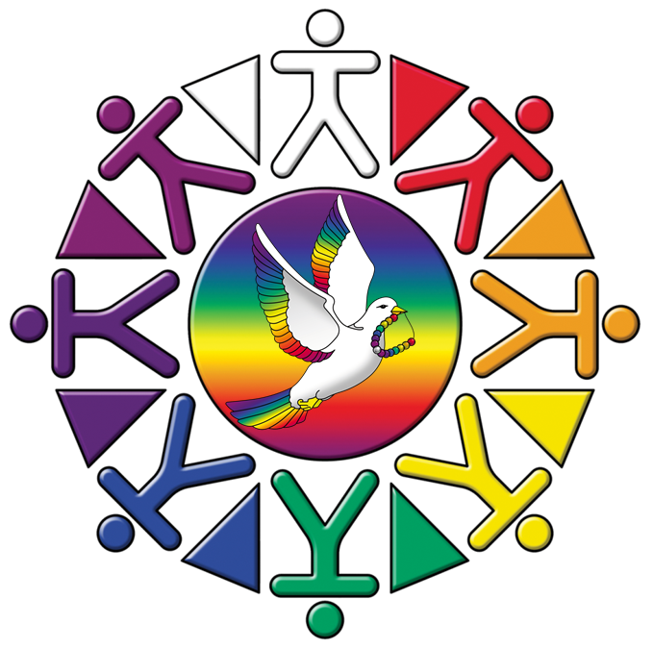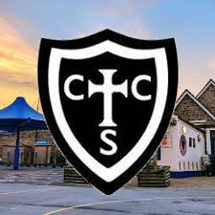

Uniting All Faiths and Communities in Peace

Hosted by Christchurch C in W VA Primary School

Thursday 18th September 2025
To start promptly at 10:30am
Please take your seats by 10:00am

Ambient sound as guests arrive inside the church: Celtic music with flutes, didgeridoo and piano played by Fr. Tim Ardouin, Leslie Sheills, and Lee Michael Walton

- Procession of Civic Dignitaries
Music: ‘The Breath of the Light’ composed and played by Lee Michael Walton on the Minster organ.

- Procession of the Faiths lead by Revd. Gaynor Jones-Higgs and Revd. Lisa Morgan with two pupils from Christchurch CW Primary School Swansea.
(Processional cross, thurible and incense at front)
Music- ‘Benedictus’ from Karl Jenkins ‘The Armed Man’ “Blessed is he that cometh in the name of the Lord. Hosanna in the Highest.”
- Words of welcome from Revd. Canon Justin Davies, Rector of Central Swansea
- A few words from Pam Evans
MBE- Founder of Peace Mala
- Peace Mala Prayer for World Peace read by Pam Evans MBE as the central white candle is lit by Revd Canon Justin Davies, Rector of Central Swansea
We share the lighting of these candles of peace as symbols of love, hope and healing for our world.
We pray for greater understanding between all people, Forgiveness for the mistakes that we have made and, Compassion for all beings of earth sky and sea. May these peace candles shine as symbols of all that is good. May our friendship grow; May peace be found within each one of us.

6. Lighting of the Peace Mala peace candles by faith representatives and pupils
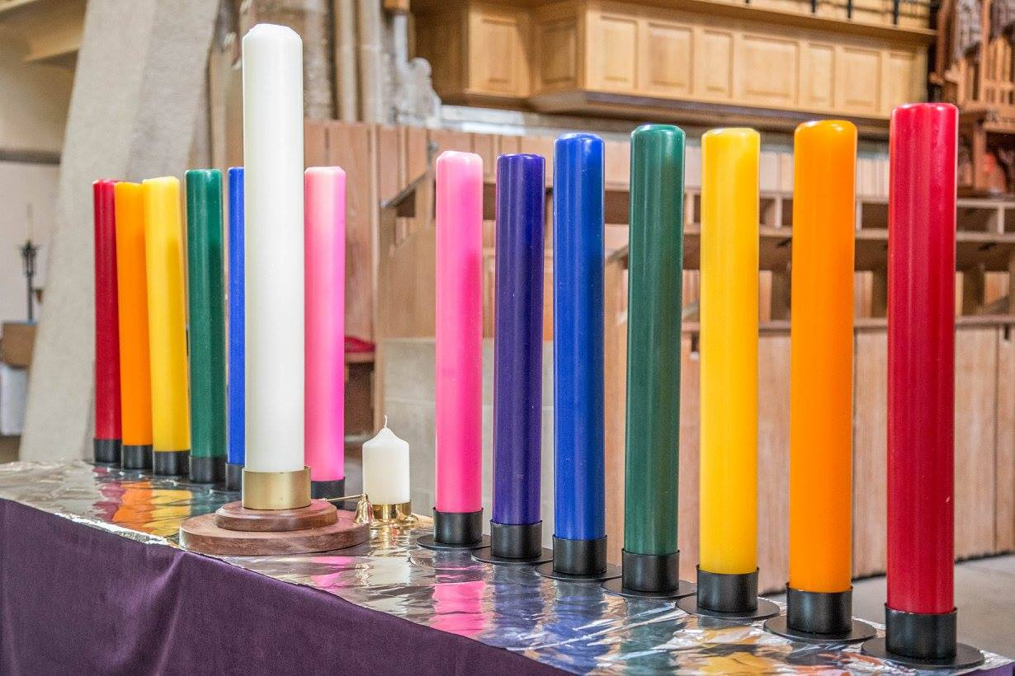
Music: Inspirational Music by Fr Tim Ardoiun, Lesley Sheills and Lee Michael Walton.

7. Messages of the Peace Mala bracelet presented by Christchurch C in W VA Primary School

















8. Peace Mala Anthem – ‘One Light’
Copyright © 2016 Music and Lyrics by Lee Michael Walton
Lead vocals by Steve Balsamo with pupils from Peace Mala schools singing and Catwg Primary School pupils will sign the lyrics.
Accompanied by Lee Michael Walton on the piano.

Stars are lighting up our path
And souls are woken
The deepest ocean
Sings the song within our hearts
As we join together
We share with each other
The key to peace throughout the world
One light to guide us
One love to hold us
See the beauty here on earth
From sunrise to sunset
Take my hand and
Dance to the light that guides us home
No words can express the beauty of the
Love, which sings throughout the lands
We share together; we care and live in peace
With each neighbour as a friend
For we behold the truth which is one Love
One Light to guide us on our way
As we journey onwards
Love is all around to show a brighter day
Take my hand and Love will show the Way
One Heart
One Love
One Light

9. Steve Balsamo – Original song ‘Tender Heart’ by Steve accompanied by professional backing track.

10. Mal Pope and Steve Balsamo – ‘For this Reason’ written by Mal Pope accompanied by professional backing track.

11. Mrs Anne- Marie Adkins – Headteacher of Christchurch Primary to introduce schools to perform their pieces.

 12. Hafod Pupils Performance
13. Llangattock Pupils Performance
14. Tan Y Lan pupils Performance

15. Lighting of votive candles for world peace
Individual votives for world peace will be lit by pupil representatives and their teachers along with faith representatives.
Pupils of Christchurch C in W VA Primary School performance while the votives are being lit.
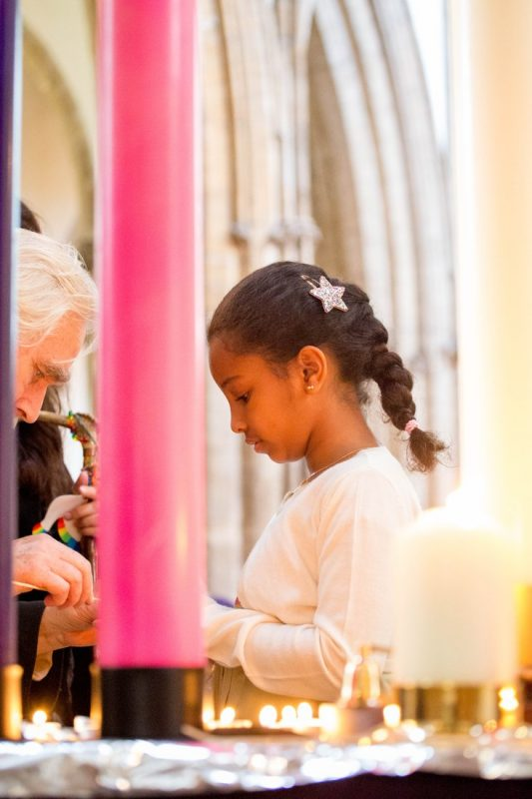

16. Collect for peace and final blessing - Revd Canon Justin Davies, Rector of Central Swansea

17. Recessional of the Christian Clergy.
Music: ‘The Rise of the Phoenix’ composed and played on the Minster Organ by Lee Michael Walton.

Thank you for your company and support today. There will be a collection taken in aid of the ministry of Swansea Minster and the work of Peace Mala.
Peace Mala thanks the rector, staff and clergy of Swansea Minster for their kind support and help in making today possible. We are also grateful to Christchurch Cin W VA Primary School for hosting and helping to organise today’s event.
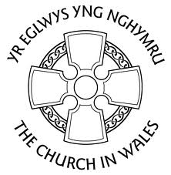
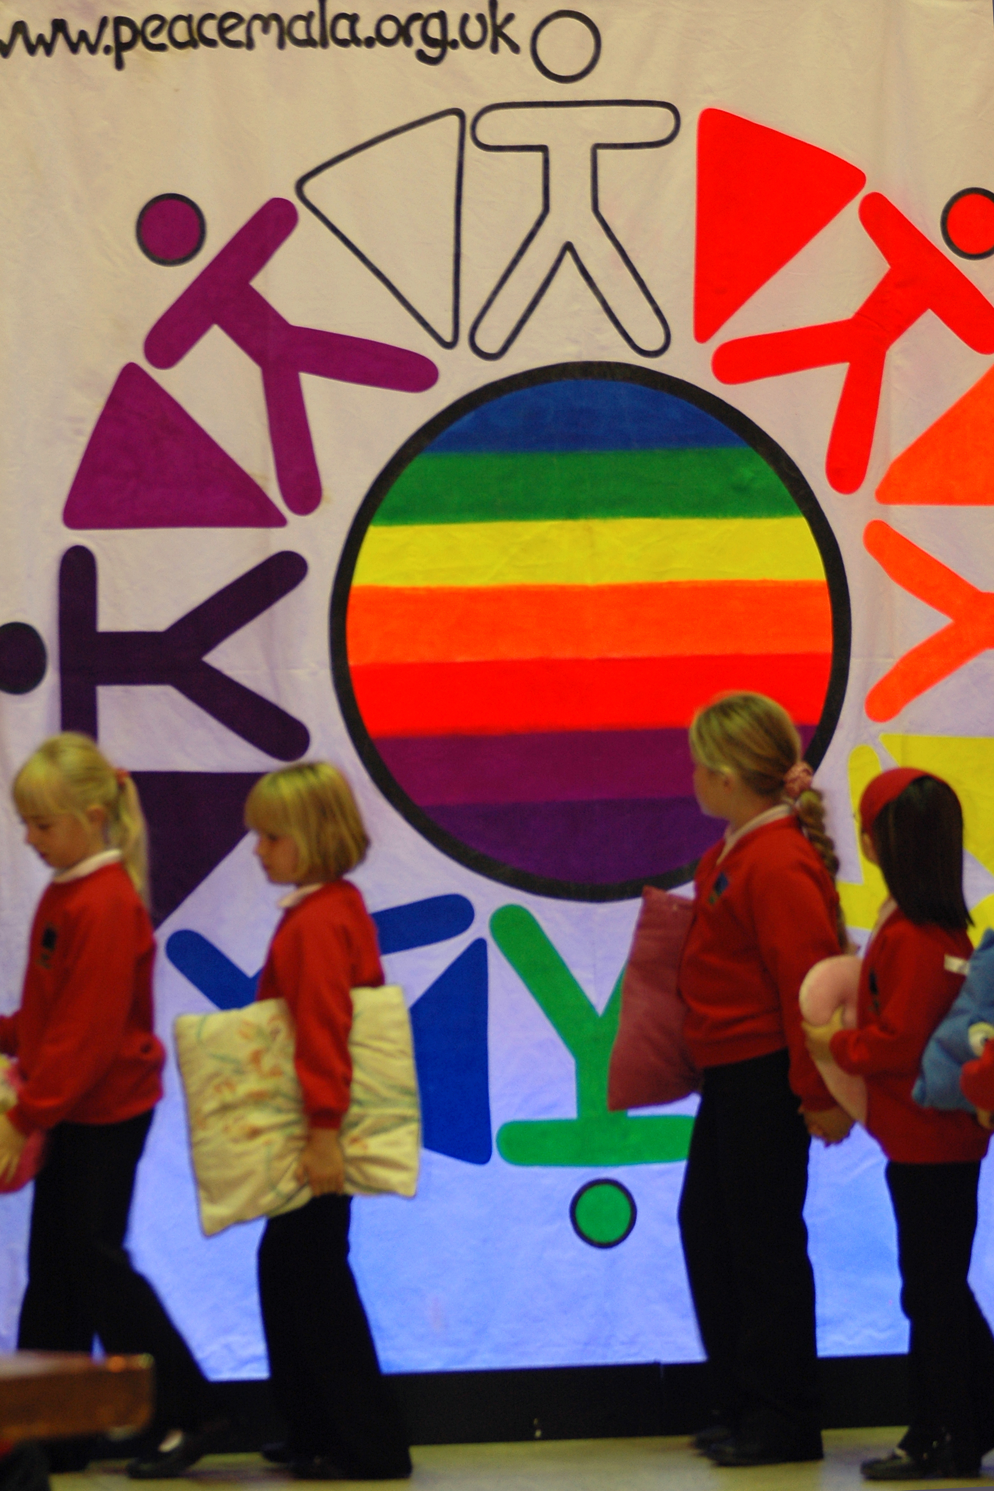
www.peacemala.org.uk
Registered Charity No. 1118053
Tel: 01792 774225
Peace Mala is a multi-award winning educational project for global citizenship.
Peace Mala supports Human Rights, stands up to bullying and all forms of prejudice.
Our compassionate wish is for people, animals and the environment to be at peace.
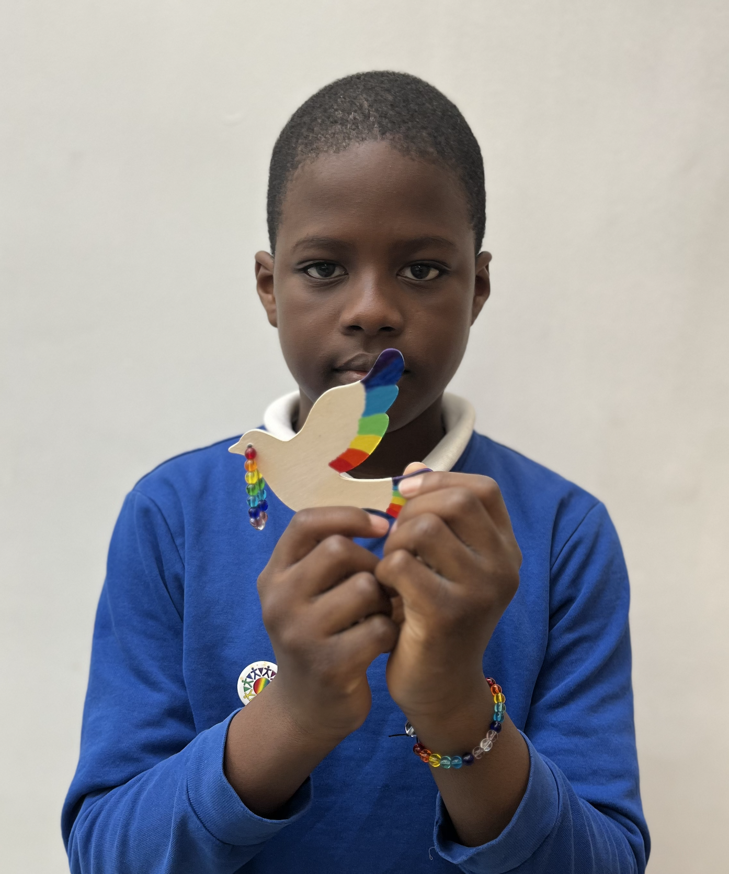
"The world if filled with much darkness and cruelty. I believe that with Peace Mala and the Golden Rule we can change things."
Ebube Divine Nwankwor - Junior Peace Mala Ambassador

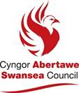
Today’s event has been supported by the Community Cohesion Small Grant Fund

