CHRISTCHURCH PRIMARY SCHOOL ECO CASE STUDY 2021 
God gave us the world. It is our responsibility to look after it, by reducing, reusing and recycling!
It has been a strange year with Covid, but our AGENTS OF CHANGE have been working hard to continue to carry out our Eco Action Plan. We reviewed and evaluated our action plan. Meetings have been on TEAMS, and we have had to keep separate. Despite this, we are proud of our ECO delivery. Have a look at our school website for more information. https://christchurch-primary-school.secure-primarysite.net/eco-warriors/
This year we really wanted to focus on recycling and reusing across the school.
Look at what we have achieved!
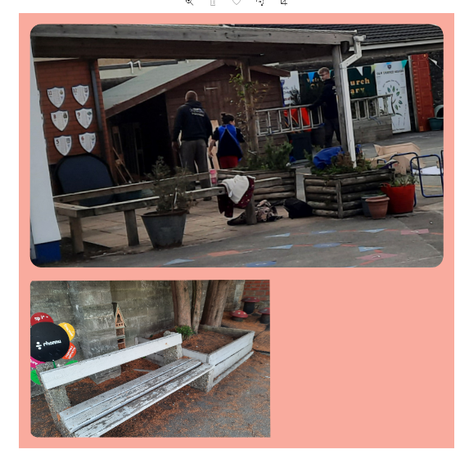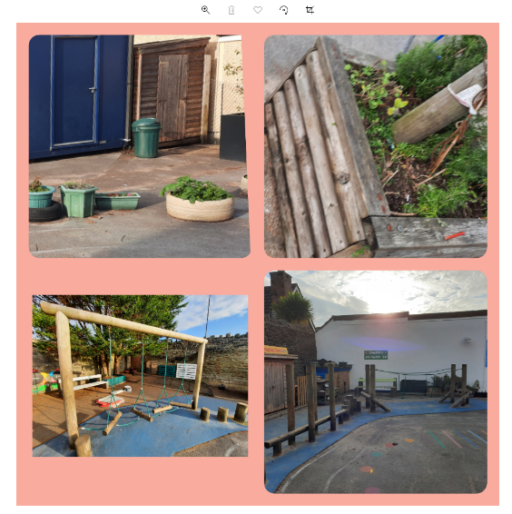
Our yard BEFORE!
The Agents of Change listened to learners views about the yard. We asked all stakeholders including the staff and governors how we can improve the yard. With lots of ideas, we decided to recycle and reuse!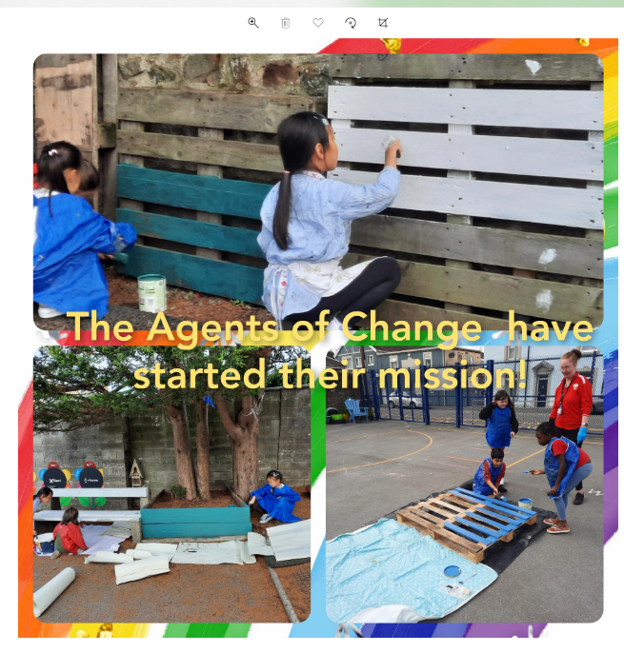
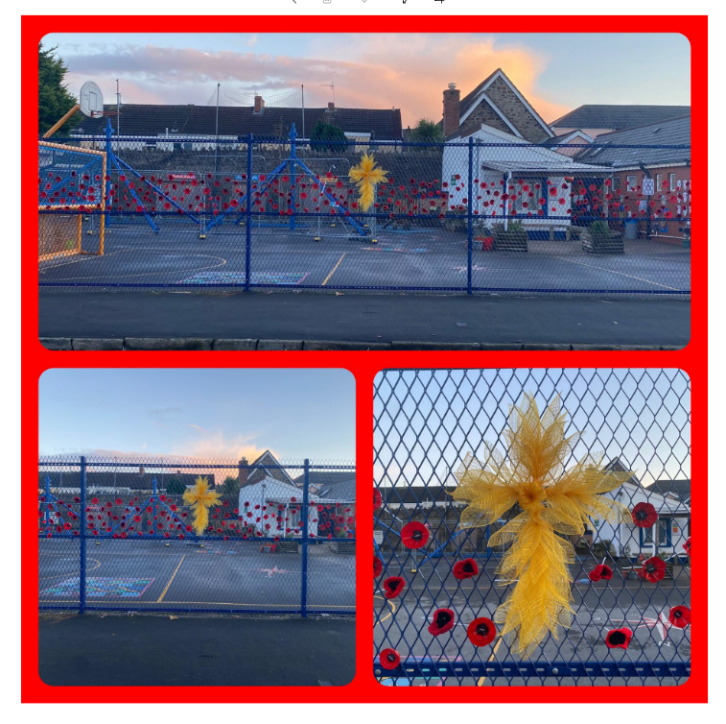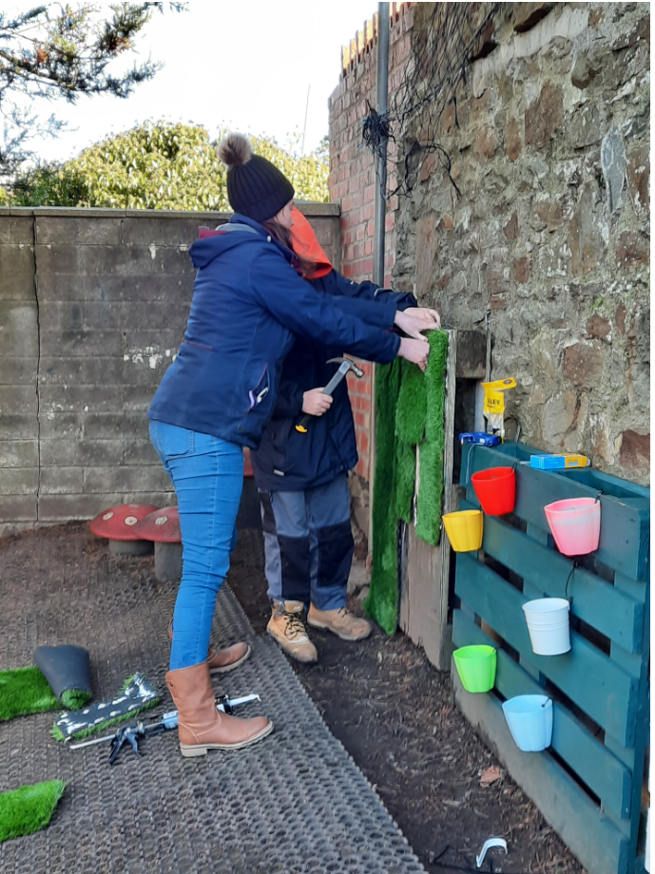
We painted plastic bottles to make 3d Poppies. Friends came to help!

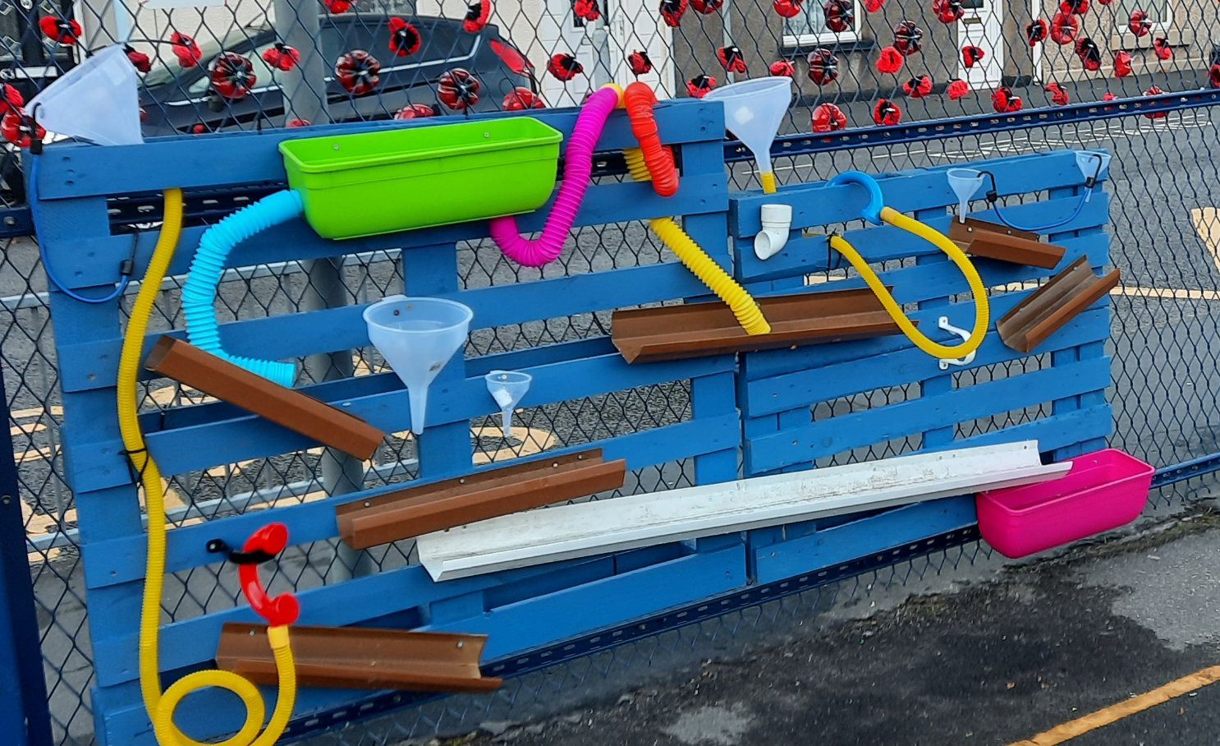
Our water wall. We recycled guttering and pots.
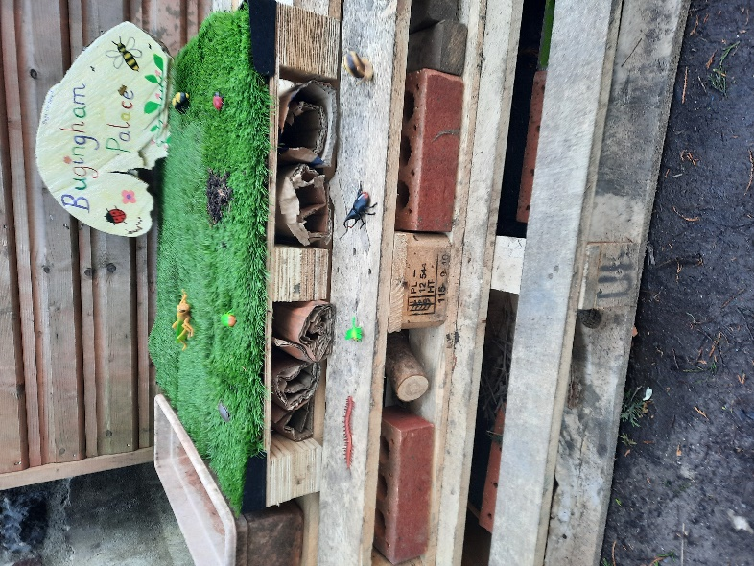
We recycled wood and building materials to make our own BUGINGHAM Palace!
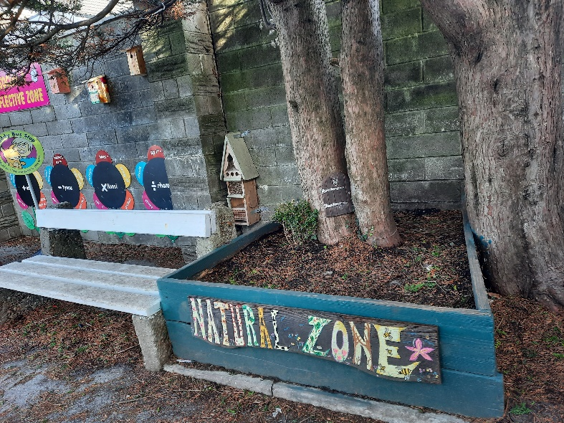
We created a Natural ZONE. Children across the school built birdhouses and planted a range of flowers and plants.
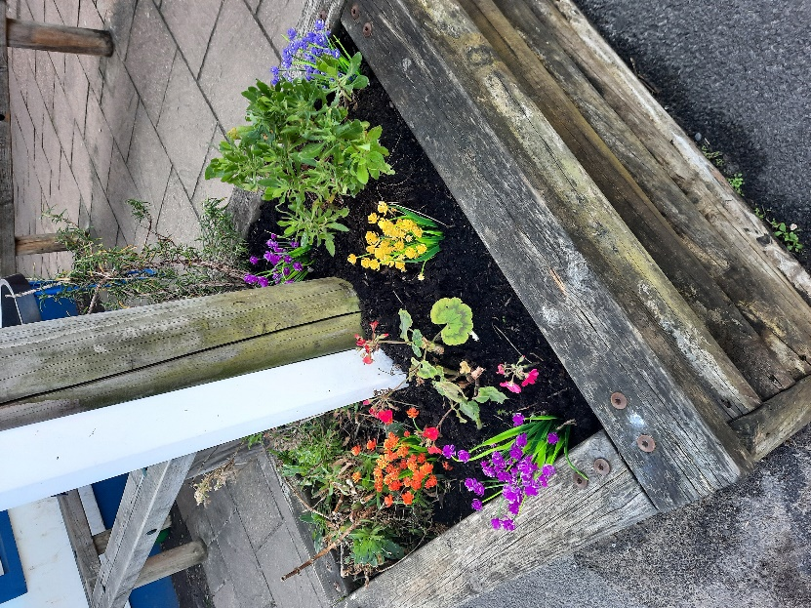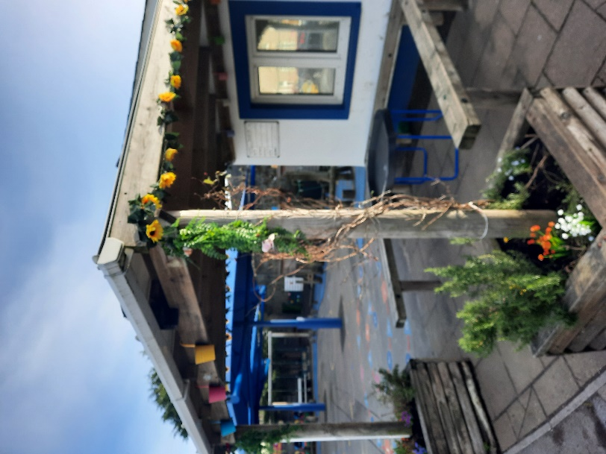

We made a Music wall. Friends of our school-donated objects to recycle and re use. We will use the wheels for weaving art.

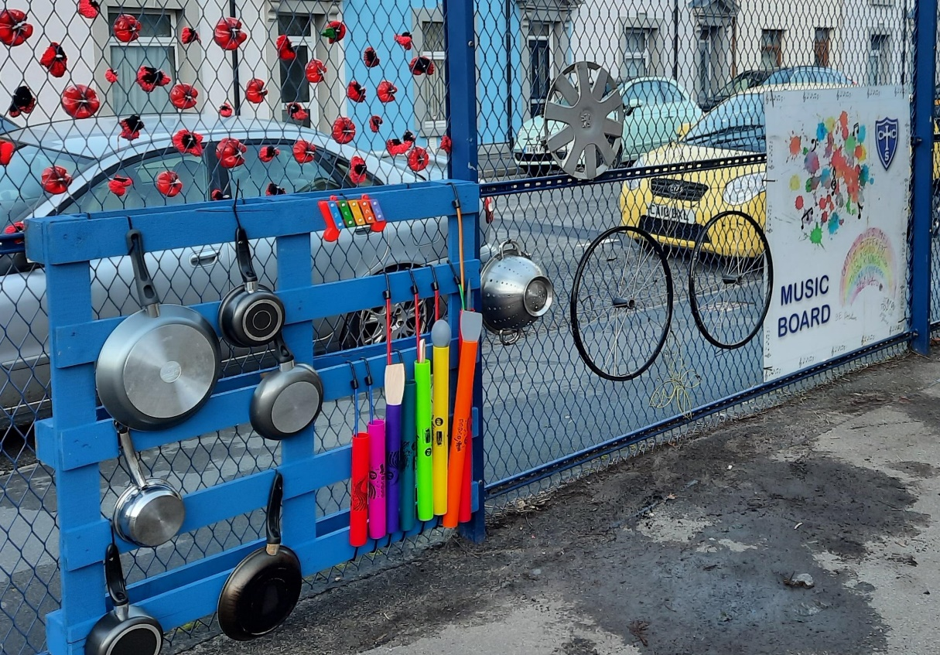
We recycled old tyres and painted them.
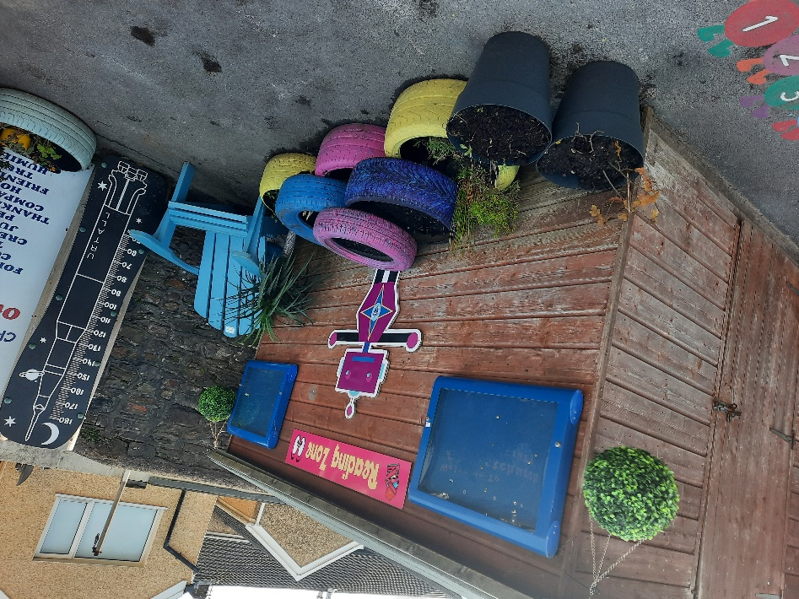
Log onto our website to see our ECO ACTION PLAN. It tells you what other ECO projects we have had fun with!
/
https://www.christchurchpri.co.uk/eco-warriors/

