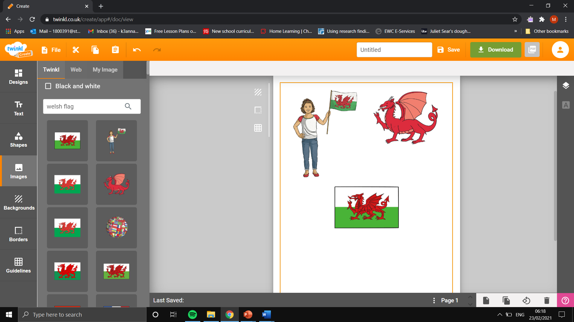
Extension Activity
Task: Write a selection of sentences on Wales. This could be on the food, sports, songs, people or why you proud to be Welsh.

Hobbies - hobÏau
What is your hobby? - Beth ydy dy hobi ?
I like…playing rugby - Dw i’n hoffi… chwarae rugbi.
I enjoy watching rugby - Dw i’n mwynhau gwylio rygbi.
I like reading - Dw I’n hoffi darllen.

Food - Bwyd
What is your favourite food? - Beth yw dy hoff fwyd?
I like … - Dw i’n hoffi …
My favourite food is ... - Fy hoff fwyd yw ...
My favourite food is fish and chips - Fy hoff fwyd yw pysgod a sglodion.

Proud to be Welsh - Yn falch o fod yn Gymraeg
I am proud to come from Wales - Dw i’n falch i ddod o Gymru.
I am proud I live in Wales - Dw i’n falch dw I’n byw yng Nghymru.

Key Words- Geiriau allweddol

Welsh Cakes - Cacennau Cymraeg. | Singing -  Canu. | Choir -  Côr. | Walking -  Cerdded.
Daffodil-  Cennin Pedr. | Leek-  Genhinen. | Rugby-  Rugbi. | Football-  Pêl-droed.
Vegetables-  Llysiau. | Fruit-  Ffrwythau. | Milk-  Llaeth. | Cheese-  Caws.

