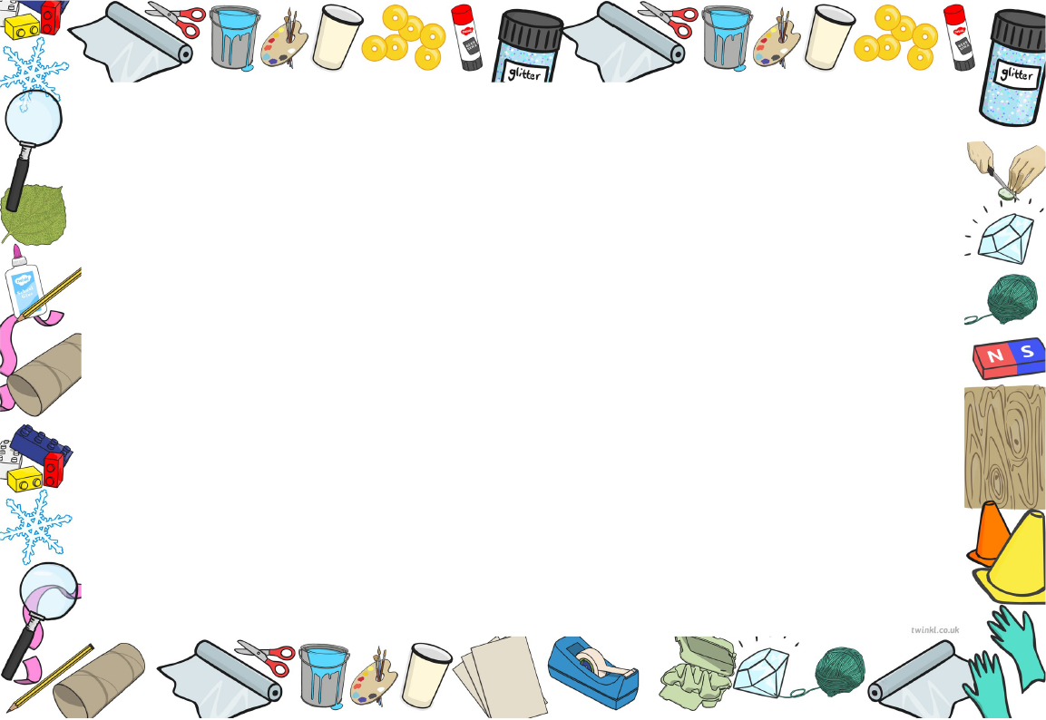
The Parachute Experiment
Learning objective: to use my knowledge of materials to predict outcomes.
Task: describe what is being investigated in the parachute experiment.
What is being investigated?

Material | Plastic | Metal | Paper | Polyester (fabric) | Cardboard
Prediction
Outcome
Task: tick the box of the material that you predict will be the slowest and softest parachute landing. Then watch the experiment video and record the times of the landings in the outcome box.

Task: Explain your prediction. What properties does the material have that you believe will be good for a parachute. Were you correct in your prediction? What is your final answer for the best material for a parachute?

