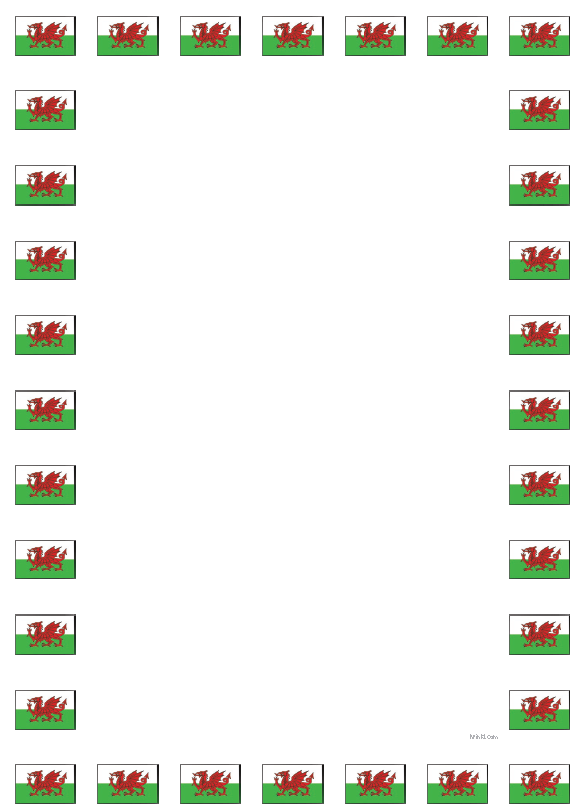
Questions and Answers Cwestiynau ac Atebion
Learning Objective: To ask and answer a range of questions using the correct sentence patterns.
Questions Cwestiynau | Answers Atebion
Who are you?Pwy wyt ti? | I am… … dw i.
Name Enw

Age Oed
Questions Cwestiynau | Answers Atebion | Numbers Rhifau
How old are you?  Faint ydy dy oed di? | I am … years old.  Dw i’n … oed. | Seven Saith
How old are you?  Faint ydy dy oed di? | I am … years old.  Dw i’n … oed. | Eight Wyth
How old are you?  Faint ydy dy oed di? | I am … years old.  Dw i’n … oed. | Nine Naw
How old are you?  Faint ydy dy oed di? | I am … years old.  Dw i’n … oed. | Ten Deg
How old are you?  Faint ydy dy oed di? | I am … years old.  Dw i’n … oed. | Eleven undeg un

Home Adref
Questions Cwestiynau | Answers Atebion | Places Lleoedd
Where do you live?  Ble wyt ti’n byw? | I live in …  Dw I’n byw yn … | Swansea Abertawe
Where do you live?  Ble wyt ti’n byw? | I live in …  Dw I’n byw yn … | Neath Castell-nedd
Where do you live?  Ble wyt ti’n byw? | I live in …  Dw I’n byw yn … | Wales Cymru

Feelings Theimladau
Questions Cwestiynau | Answers Atebion | Feelings Theimladau
How are you?  Sut wyt ti? | I am …  Dw i’n … | Happy Hapus
How are you?  Sut wyt ti? | I am …  Dw i’n … | Sad Drist
How are you?  Sut wyt ti? | I am …  Dw i’n … | Tired Wedi blino
How are you feeling today?  Sut wyt ti’n teimlo heddiw? | I am …  Dw i’n … | Angry Grac
How are you feeling today?  Sut wyt ti’n teimlo heddiw? | I am …  Dw i’n … | Nervous Nerfus
How are you feeling today?  Sut wyt ti’n teimlo heddiw? | I am …  Dw i’n … | Fantastic Gwych

Colours Lliwiau

Questions Cwestiynau | Answers Atebion | Colours Lliwiau
What is your favourite colour?  Beth ydy dy hoff lliw? | My favourite colour is ...  Fy hoff liw ydy ... | Red Coch
What is your favourite colour?  Beth ydy dy hoff lliw? | My favourite colour is ...  Fy hoff liw ydy ... | Yellow Melyn
What is your favourite colour?  Beth ydy dy hoff lliw? | My favourite colour is ...  Fy hoff liw ydy ... | Blue Glas
What colour is this?  Pa liw ydy hwn? | It is …  Mae hi’n … | Green Gwyrdd
What colour is this?  Pa liw ydy hwn? | It is …  Mae hi’n … | White Gwyn
What colour is this?  Pa liw ydy hwn? | It is …  Mae hi’n … | Black Du
What colour is this?  Pa liw ydy hwn? | It is …  Mae hi’n … | Purple Porffor
Weather Tywydd
Questions Cwestiynau | Answers Atebion | Weather Tywydd
How is the weather today?  Sut mae’r tywydd heddiw? | It is …  Mae hi’n … | Sunny Heulog
How is the weather today?  Sut mae’r tywydd heddiw? | It is …  Mae hi’n … | Raining Bwrw glaw
How is the weather today?  Sut mae’r tywydd heddiw? | It is …  Mae hi’n … | Stormy Stormus
How is the weather today?  Sut mae’r tywydd heddiw? | It is …  Mae hi’n … | Snowing Bwrw eira
How is the weather today?  Sut mae’r tywydd heddiw? | It is …  Mae hi’n … | Cold oer
How is the weather today?  Sut mae’r tywydd heddiw? | It is …  Mae hi’n … | Hot Poeth

Questions Cwestiynau | Answers Atebion | Clothes Dillad
What are you wearing?  Beth wyt ti’n wisgo? | I am wearing…  Dw i’n gwisgo… | Trousers Trwser
What are you wearing?  Beth wyt ti’n wisgo? | I am wearing…  Dw i’n gwisgo… | Skirt Sgert
What are you wearing?  Beth wyt ti’n wisgo? | I am wearing…  Dw i’n gwisgo… | Dress Ffrog
What are you wearing?  Beth wyt ti’n wisgo? | I am wearing…  Dw i’n gwisgo… | Jumper Siwmper
What are you wearing?  Beth wyt ti’n wisgo? | I am wearing…  Dw i’n gwisgo… | T-shirt Crys t
What are you wearing?  Beth wyt ti’n wisgo? | I am wearing…  Dw i’n gwisgo… | Shoes Esgidiau
Clothes Dillad

Questions Cwestiynau | Answers Atebion | Food Bwyd
What is your favourite food?  Beth ydy dy hoff bwyd? | My favourite food is …  Fy hoff fwyd ydy … | Fruit Ffrwythau
What is your favourite food?  Beth ydy dy hoff bwyd? | My favourite food is …  Fy hoff fwyd ydy … | Vegetables Llysiau
What is your favourite food?  Beth ydy dy hoff bwyd? | My favourite food is …  Fy hoff fwyd ydy … | Cake Cacen
What is your favourite food?  Beth ydy dy hoff bwyd? | My favourite food is …  Fy hoff fwyd ydy … | Chips Sglodion
What food would you like?  Pa fwyd hoffech chi? | I like …  Dw i’n hoffi… | Peas Pys
What food would you like?  Pa fwyd hoffech chi? | I like …  Dw i’n hoffi… | Fish Pysgod
What food would you like?  Pa fwyd hoffech chi? | I like …  Dw i’n hoffi… | Cheese Caws
Food Bwyd

Hobbies HobÏau
Questions Cwestiynau | Answers Atebion | Hobbies HobÏau
What is your hobby?  Beth ydy dy hobi? | My hobby is …  Fy hobi ydy … | Gymnasteg Gymnastics
What is your hobby?  Beth ydy dy hobi? | My hobby is …  Fy hobi ydy … | Peintio Painting
Do you like …?  Wyt ti’n hoffi …? | Yes, I like…..  Ydw, dw i’n hoffi … | Merlota Horse riding
Do you like …?  Wyt ti’n hoffi …? | Yes, I like…..  Ydw, dw i’n hoffi … | Gwau Knitting
Do you like …?  Wyt ti’n hoffi …? | No, I don’t like…  Nac ydw, dw i ddim yn hoffi… | Coginio Cooking
Do you like …?  Wyt ti’n hoffi …? | No, I don’t like…  Nac ydw, dw i ddim yn hoffi… | Carati Karate
What do you like doing in your spare time?  Beth wyt ti’n hoffi wneud yn dy amser hamdden? | I like …  Dw i’n hoffi… | Dallen Reading
 | I like …  Dw i’n hoffi… | Canu Singing
 | I like …  Dw i’n hoffi… | Seiclo Cycling

