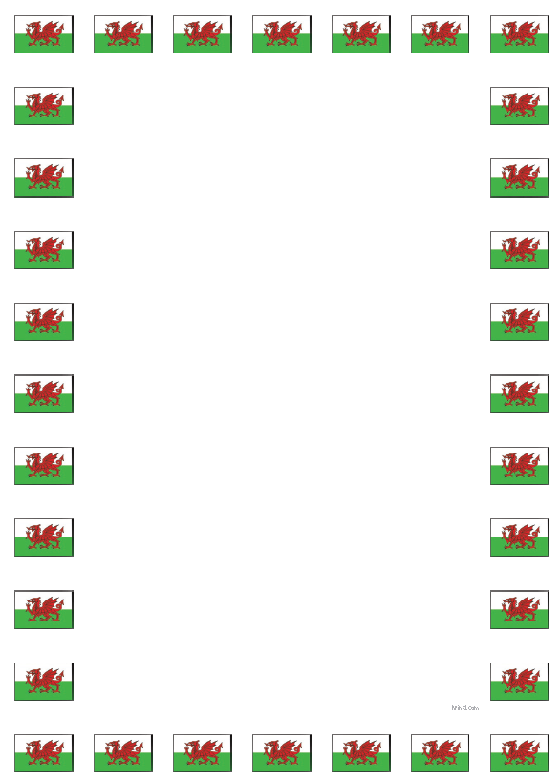
Questions and Answers Cwestiynau ac Atebion

Learning Objective: To ask and answer a range of questions using the correct sentence patterns.
Task: Fill in and answer the missing questions and answers.
Questions Cwestiynau | Answers Atebion
Who are you?
Pwy wyt ti?

I am … years old.
Dw i’n … oed.
Where do you live?
Ble wyt ti’n byw?
I am …
Dw i’n …
What is your favourite colour?
Beth ydy dy hoff lliw?

It is …
Mae hi’n …
What are you wearing?
Beth wyt ti’n wisgo?
My favourite food is …
Fy hoff fwyd ydy …
What is your hobby?
Beth ydy dy hobi?

