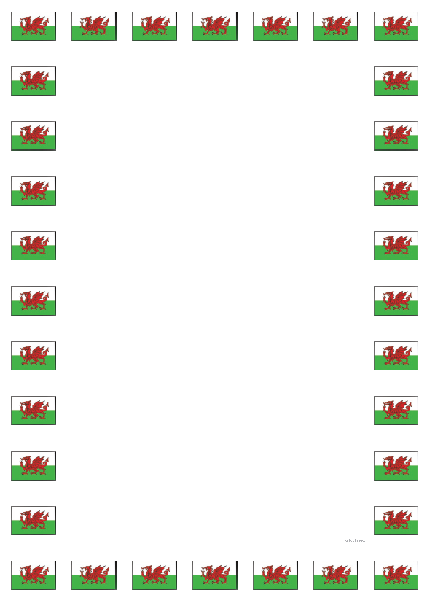
Questions and Answers Cwestiynau ac Atebion

Learning Objective: To ask and answer a range of questions using the correct sentence patterns.
Task: Answer the questions using the support sheet.
Questions Cwestiynau | Answers Atebion
Who are you?  Pwy wyt ti? | I am ...  … dw i.
How old are you?  Faint ydy dy oed di? | I am … years old.  Dw i’n … oed.
Where do you live?  Ble wyt ti’n byw? | I live in …  Dw I’n byw yn …
How are you feeling today?  Sut wyt ti’n teimlo heddiw? | I am …  Dw i’n …
What is your favourite colour?  Beth ydy dy hoff lliw? | My favourite colour is ...  Fy hoff liw ydy...
How is the weather today?  Sut mae’r tywydd heddiw? | It is …  Mae hi’n …
What are you wearing?  Beth wyt ti’n wisgo? | I am wearing…  Dw i’n gwisgo…
What is your favourite food?  Beth ydy dy hoff bwyd? | My favourite food is …  Fy hoff fwyd ydy …
What is your hobby?  Beth ydy dy hobi? | My hobby is …  Fy hobi ydy …

